## CodeBuild – buildspec.yml

* buildspec.yml file must be at the root of your code
* env – define environment variables
  + variables – plaintext variables
  + parameter-store – variables stored in SSM Parameter Store
  + secrets-manager – variables stored in AWS Secrets Manager
* phases – specify commands to run:
  + install – install dependencies you may need for your build
  + pre_build – final commands to execute before build
  + Build – actual build commands
  + post_build – finishing touches (e.g., zip output)
* artifacts – what to upload to S3 (encrypted with KMS)
* cache – files to cache (usually dependencies) to S3 for future build speedup

## CodeBuild – Local Build

* In case of need of deep troubleshooting beyond logs…
* You can run CodeBuild locally on your desktop (after installing Docker)
* For this, leverage the CodeBuild Agent
* https://docs.aws.amazon.com/codebuild/latest/userguide/use-codebuild- agent.html

## CodeBuild – Inside VPC

* By default, your CodeBuild containers are launched outside your VPC

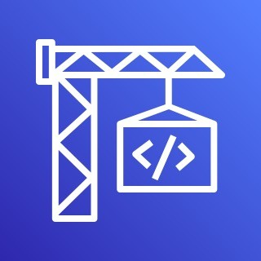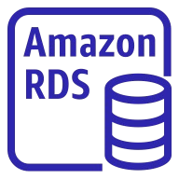

VPC

Private Subnet

CodeBuild

**CodeBuild Container**

RDS DB

Instance

* + It cannot access resources in a VPC
* You can specify a VPC configuration:
  + VPC ID
  + Subnet IDs
  + Security Group IDs
* Then your build can access resources in your VPC (e.g., RDS, ElastiCache, EC2, ALB, …)
* Use cases: integration tests, data query, internal load balancers, …

## AWS CodeDeploy

* We want to deploy our application automatically to many EC2 instances

v2

v1

* These EC2 instances are not managed by Elastic Beanstalk

v2

v1

* There are several ways to handle deployments using open-source tools (Ansible,Terraform, Chef, Puppet, …)

v2

v1

* We can use the managed service AWS CodeDeploy

v2

v1

## CodeDeploy – Steps To Make it Work

* Each EC2 instance/on-premises server must be running the CodeDeploy Agent

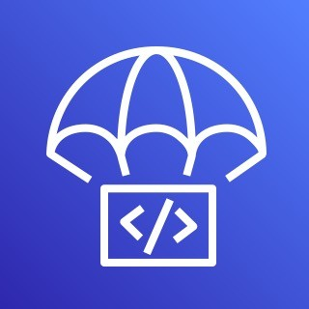

Source code

+

…

appspec.yml

**Revision Location**

OR

Amazon S3

GitHub

1. push

Developer

2. trigger

4. Download

3. poll

* The agent is continuously polling AWS CodeDeploy for work to do
* Application + appspec.yml is pulled from GitHub or S3
* EC2 instances will run the deployment instructions in appspec.yml

|  |  |
| --- | --- |
| Code + appspec.yml |  |
| EC2 Instances On-premises Servers  **(CodeDeploy Agent) (CodeDeploy Agent)** |  |
|  |  |

* CodeDeploy Agent will report of success/failure of the deployment

©

AWS CodeDeploy



## CodeDeploy – Primary Components

* Application – a unique name functions as a container (revision, deployment configuration, …)
* Compute Platform – EC2/On-Premises, AWS Lambda, or Amazon ECS
* Deployment Configuration – a set of deployment rules for success/failure
  + EC2/On-premises – specify the minimum number of healthy instances for the deployment
  + AWS Lambda or Amazon ECS – specify how traffic is routed to your updated versions
* Deployment Group - group of tagged EC2 instances (allows to deploy gradually, or dev, test, prod…)
* Deployment Type – method used to deploy the application to a Deployment Group
  + In-place Deployment – supports EC2/On-Premises
  + Blue/Green Deployment – supports EC2 instances only, AWS Lambda, and Amazon ECS
* IAM Instance Profile – give EC2 instances the permissions to access both S3 / GitHub
* Application Revision – application code + appspec.yml file
* Service Role – an IAM Role for CodeDeploy to perform operations on EC2 instances, ASGs, ELBs…
* Target Revision – the most recent revision that you want to deploy to a Deployment Group

## CodeDeploy – appspec.yml

* files – how to source and copy from S3 / GitHub to filesystem

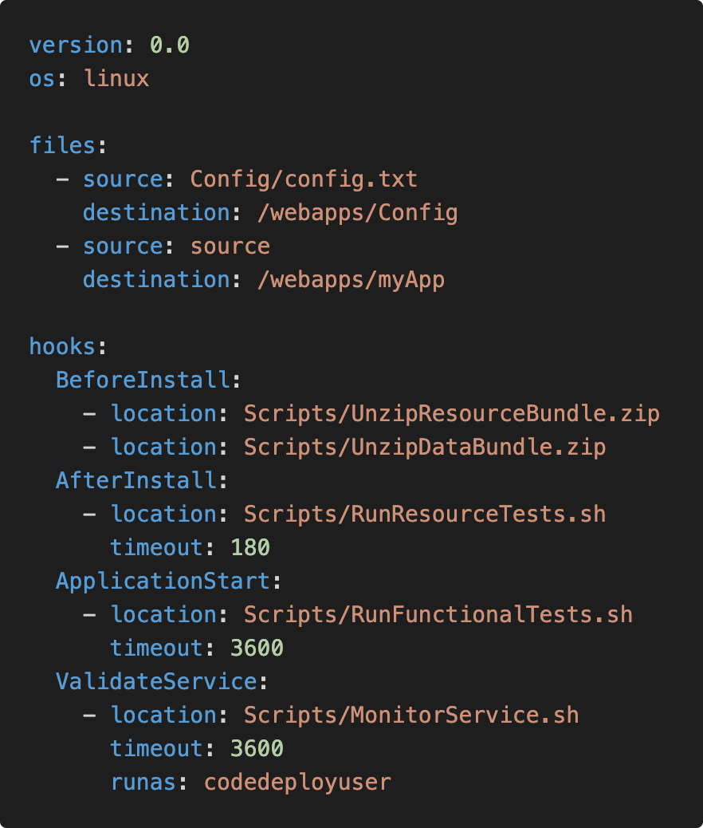

* + source
  + destination
* hooks – set of instructions to do to deploy the new version (hooks can have timeouts), the order is:
  + ApplicationStop
  + DownloadBundle
  + BeforeInstall
  + Install
  + AfterInstall
  + ApplicationStart
  + ValidateService ⬅ important!!

©k

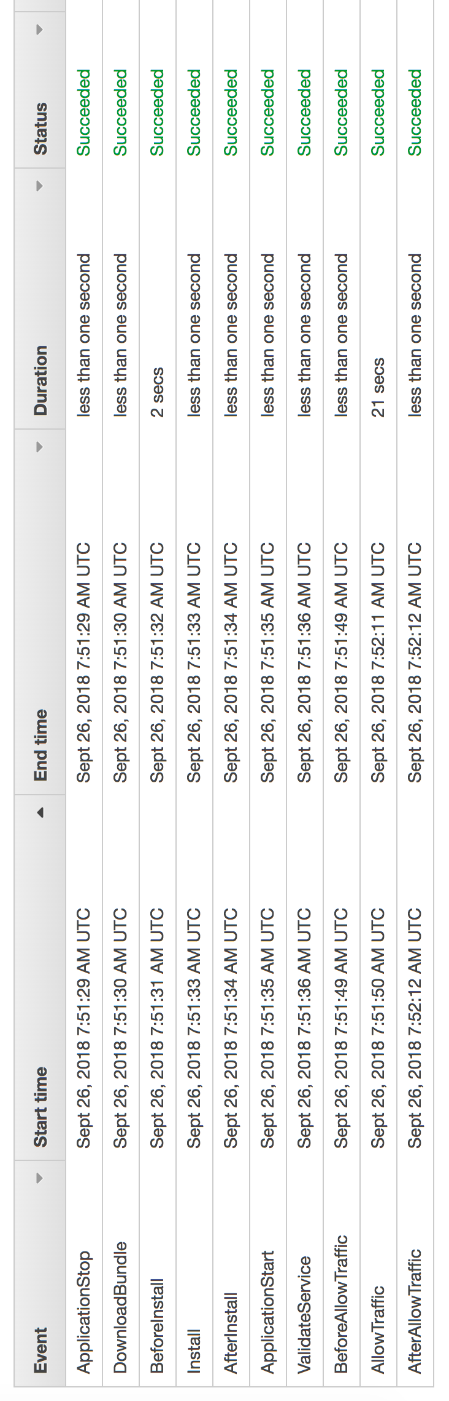

AWS CodeDeploy Deploy & Hooks Order

©Maarek

## CodeDeploy – Deployment Configuration

* Configurations:
  + One At A Time – one EC2 instance at a time, if one instance fails then deployment stops
  + Half At A Time – 50%
  + All At Once – quick but no healthy host, downtime. Good for dev
  + Custom – min. healthy host = 75%
* Failures:
  + EC2 instances stay in “Failed” state
  + New deployments will first be deployed to failed instances
  + To rollback, redeploy old deployment or enable automated rollback for failures
* Deployment Groups:
  + A set of tagged EC2 instances
  + Directly to an ASG
  + Mix of ASG / Tags so you can build deployment segments
  + Customization in scripts with DEPLOYMENT_GROUP_NAME environment variables

## CodeDeploy – In-Place Deployment

v1

v1

v2

v1

v1

v1

v1

v2

v2

v2

v2

Other Half

Half At A Time

v2

v2

v2

Half

v1

v1

## CodeDeploy – Blue-Green Deployment

Auto Scaling Group Auto Scaling Group



v1

v1

Application v1 Load Balancer

v1

©e

v1

Application v1 Load Balancer

v2

Application Load Balancer

v2

v2

v2

v2

v2

Auto Scaling Group

Auto Scaling Group



## CodeDeploy – Deployment to EC2

* Define how to deploy the application using appspec.yml + Deployment Strategy

v1

v1

v2

v2

v2

Half

* Will do In-place update to your fleet of EC2 instances

v1

v2

v1

v1

v1

v2

v2

v2

* Can use hooks to verify the deployment after each deployment phase

v1

v1

v2

Other Half

## CodeDeploy – Deploy to an ASG

Blue/Green Deployment

* In-place Deployment
  + Updates existing EC2 instances
  + Newly created EC2 instances by an ASG will also get automated deployments
* Blue/Green Deployment
  + A new Auto-Scaling Group is created (settings are copied)
  + Choose how long to keep the old EC2 instances (old ASG)
  + Must be using an ELB



Application Load Balancer



EC2 Instances EC2 Instances

(Launch Template **v1**) (Launch Template **v2**)

Auto Scaling Group



AWS CodeDeploy

## CodeDeploy – Redeploy & Rollbacks

* Rollback = redeploy a previously deployed revision of your application
* Deployments can be rolled back:
  + Automatically – rollback when a deployment fails or rollback when a CloudWatch Alarm thresholds are met
  + Manually
* Disable Rollbacks — do not perform rollbacks for this deployment
* If a roll back happens, CodeDeploy redeploys the last known good revision as a new deployment (not a restored version)

## AWS CodeStar

* An integrated solution that groups: GitHub, CodeCommit, CodeBuild, CodeDeploy, CloudFormation, CodePipeline, CloudWatch, …
* Quickly create “CICD-ready” projects for EC2, Lambda, Elastic Beanstalk
* Supported languages: C#, Go, HTML 5, Java, Node.js, PHP, Python, Ruby
* Issue tracking integration with JIRA / GitHub Issues
* Ability to integrate with Cloud9 to obtain a web IDE (not all regions)
* One dashboard to view all your components
* Free service, pay only for the underlying usage of other services
* Limited Customization

## AWS CodeArtifact

* Software packages depend on each other to be built (also called code dependencies), and new ones are created
* Storing and retrieving these dependencies is called artifact management
* Traditionally you need to setup your own artifact management system
* CodeArtifact is a secure, scalable, and cost-effective artifact management for software development
* Works with common dependency management tools such as Maven, Gradle, npm, yarn, twine, pip, and NuGet
* Developers and CodeBuild can then retrieve dependencies straight from CodeArtifact

## AWS CodeArtifact

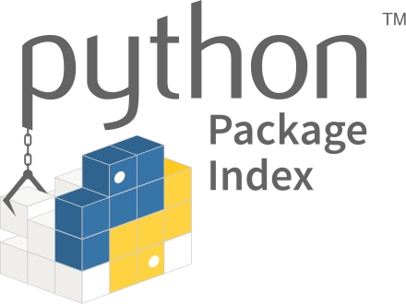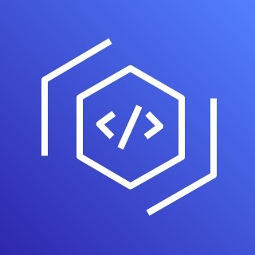

Public Artifact Repositories

NuGet

proxy

VPC

fetch

AWS CodeBuild

npm

pip

JavaScript

Python

IT Leader

AWS CodeArtifact

Domain

**Repository B**

Package 2

**Repository A**

Package 1

publish/approve packages

NuGet

Maven

.NET

Java

## Amazon CodeGuru

* An ML-powered service for automated code reviews and application performance recommendations
* Provides two functionalities
  + CodeGuru Reviewer: automated code reviews for static code analysis (development)
  + CodeGuru Profiler: visibility/recommendations about application performance during runtime (production)

**CodeGuru Reviewer CodeGuru Profiler**

Detect and optimize



Identify performance

Built-in code reviews with actionable recommendations

the expensive lines of code pre-prod

and cost improvements in production

Coding

Build & Test Deploy Measure

## Amazon CodeGuru Reviewer

* Identify critical issues, security vulnerabilities, and hard-to-find bugs

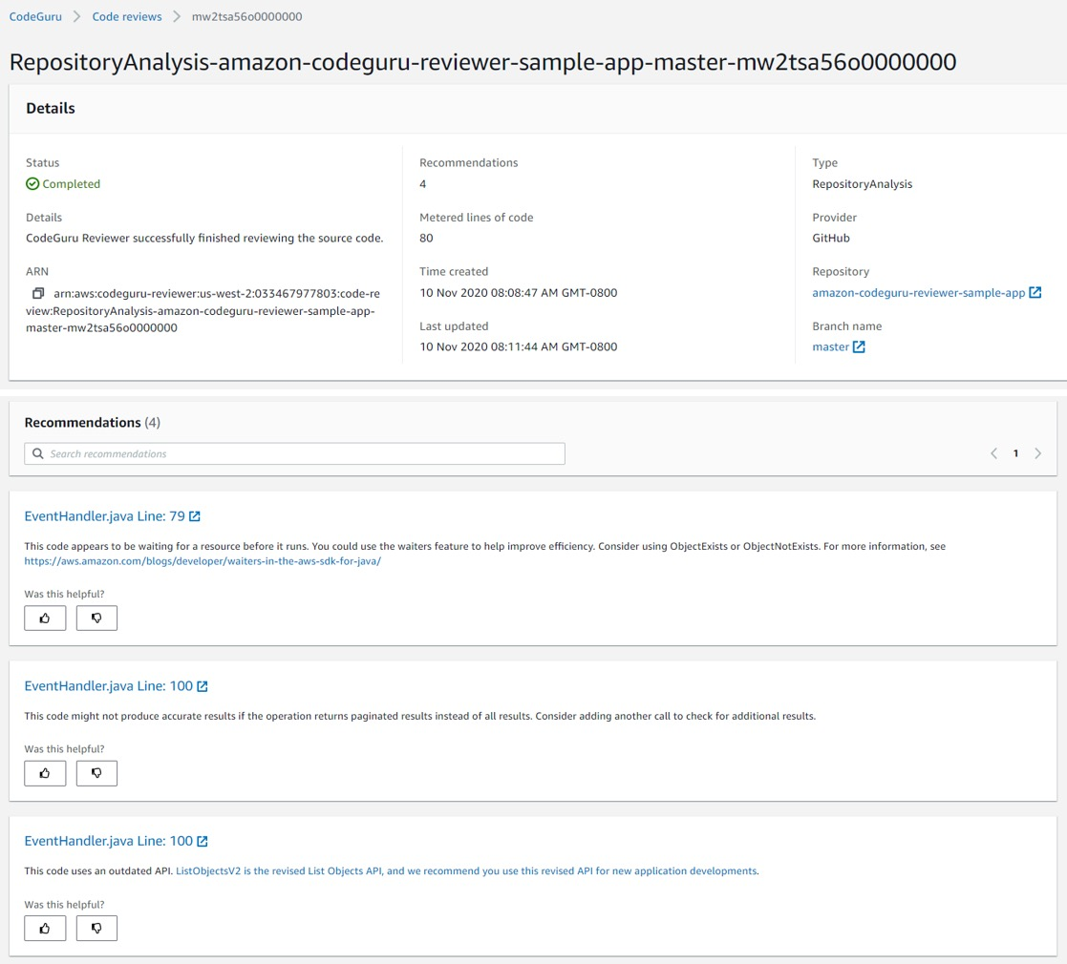

* Example: common coding best practices, resource leaks, security detection, input validation
* Uses Machine Learning and automated reasoning
* Hard-learned lessons across millions of code reviews on 1000s of open-source and Amazon repositories
* Supports Java and Python
* Integrates with GitHub, Bitbucket, and AWS CodeCommit

## Amazon CodeGuru Profiler

* Helps understand the runtime behavior of your application
* 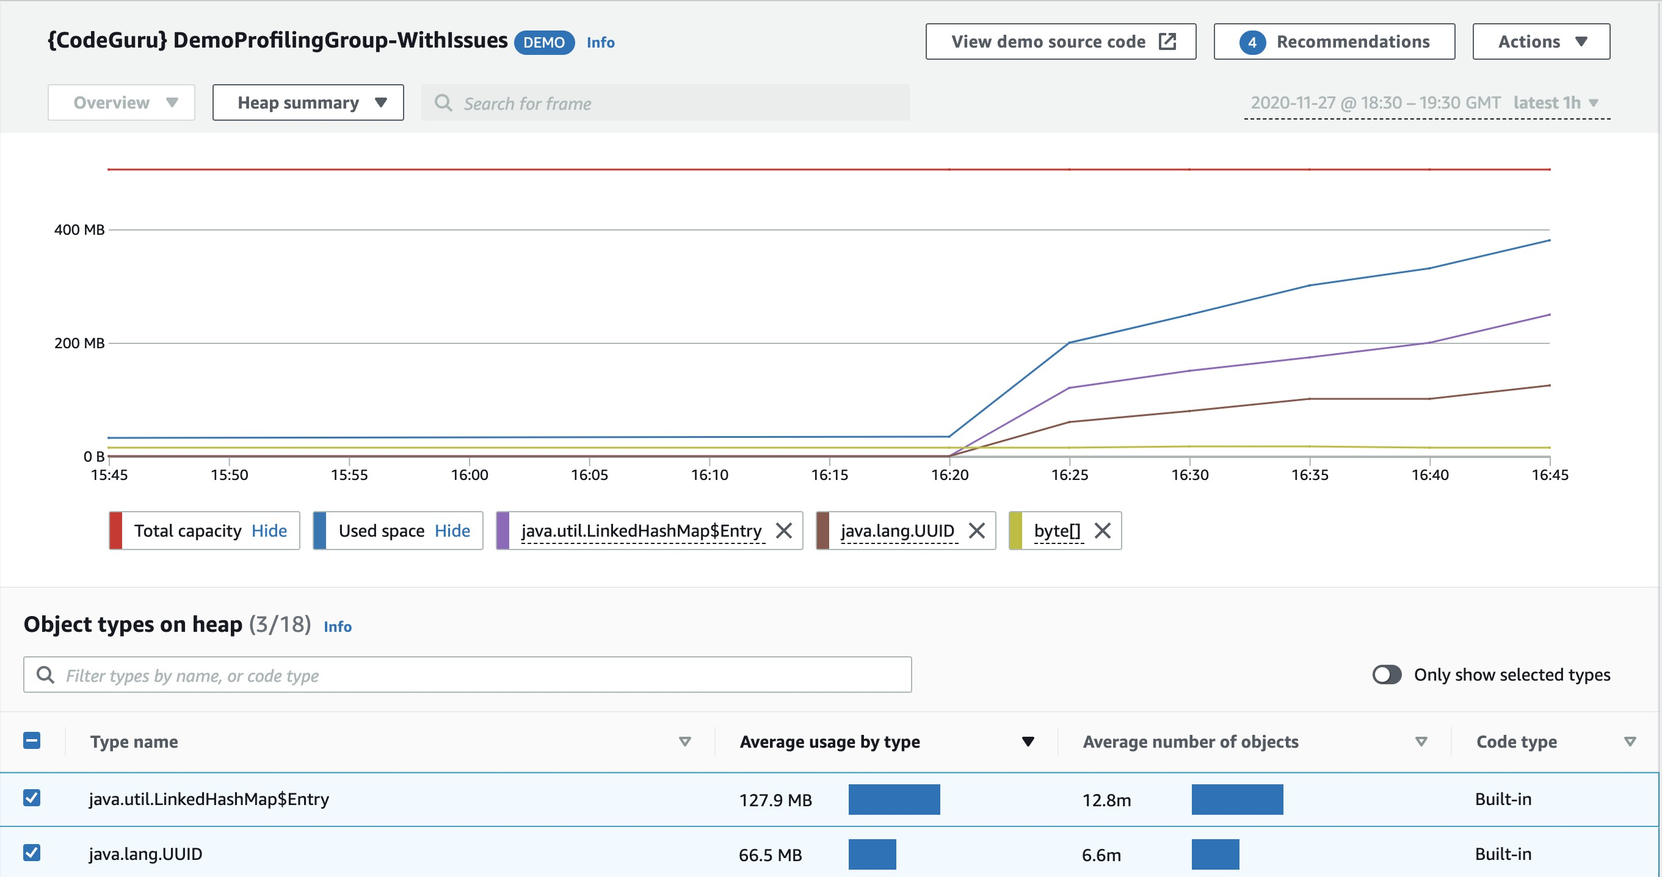Example: identify if your application is consuming excessive CPU capacity on a logging routine
* Features:
  + Identify and remove code inefficiencies
  + Improve application performance (e.g., reduce CPU utilization)
  + Decrease compute costs
  + Provides heap summary (identify which objects using up memory)
  + Anomaly Detection
* Support applications running on AWS or on- premise
* Minimal overhead on application

# AWS CloudFormation

Managing your infrastructure as code

## Infrastructure as Code

* Currently, we have been doing a lot of manual work
* All this manual work will be very tough to reproduce:
  + In another region
  + in another AWS account
  + Within the same region if everything was deleted
* Wouldn’t it be great, if all our infrastructure was… code?
* That code would be deployed and create / update / delete our infrastructure

## What is CloudFormation

* CloudFormation is a declarative way of outlining your AWS Infrastructure, for any resources (most of them are supported).
* For example, within a CloudFormation template, you say:
  + I want a security group
  + I want two EC2 machines using this security group
  + I want two Elastic IPs for these EC2 machines
  + I want an S3 bucket
  + I want a load balancer (ELB) in front of these machines
* Then CloudFormation creates those for you, in the right order, with the

exact configuration that you specify

## Benefits of AWS CloudFormation (1/2)

* Infrastructure as code
  + No resources are manually created, which is excellent for control
  + The code can be version controlled for example using git
  + Changes to the infrastructure are reviewed through code
* Cost
  + Each resources within the stack is tagged with an identifier so you can easily see how much a stack costs you
  + You can estimate the costs of your resources using the CloudFormation template
  + Savings strategy: In Dev, you could automation deletion of templates at 5 PM and recreated at 8 AM, safely

## Benefits of AWS CloudFormation (2/2)

* Productivity
  + Ability to destroy and re-create an infrastructure on the cloud on the fly
  + Automated generation of Diagram for your templates!
  + Declarative programming (no need to figure out ordering and orchestration)
* Separation of concern: create many stacks for many apps, and many layers. Ex:
  + VPC stacks
  + Network stacks
  + App stacks
* Don’t re-invent the wheel
  + Leverage existing templates on the web!
  + Leverage the documentation

## How CloudFormation Works

* Templates have to be uploaded in S3 and then referenced in CloudFormation
* To update a template, we can’t edit previous ones. We have to re- upload a new version of the template to AWS
* Stacks are identified by a name
* Deleting a stack deletes every single artifact that was created by CloudFormation.

## Deploying CloudFormation templates

* Manual way:
  + Editing templates in the CloudFormation Designer
  + Using the console to input parameters, etc
* Automated way:
  + Editing templates in a YAML file
  + Using the AWS CLI (Command Line Interface) to deploy the templates
  + Recommended way when you fully want to automate your flow

## CloudFormation Building Blocks

Templates components (one course section for each):

1. Resources: your AWS resources declared in the template (MANDATORY)
2. Parameters: the dynamic inputs for your template
3. Mappings: the static variables for your template
4. Outputs: References to what has been created
5. Conditionals: List of conditions to perform resource creation
6. Metadata

Templates helpers:

1. References
2. Functions

## Note:

This is an introduction to CloudFormation

* It can take over 3 hours to properly learn and master CloudFormation
* This section is meant so you get a good idea of how it works
* We’ll be slightly less hands-on than in other sections
* We’ll learn everything we need to answer questions for the exam
* The exam does not require you to actually write CloudFormation
* The exam expects you to understand how to read CloudFormation

## Introductory Example

* We’re going to create a simple EC2 instance.
* Then we’re going to create to add an Elastic IP to it
* And we’re going to add two security groups to it
* For now, forget about the code syntax.
* We’ll look at the structure of the files later on



**EC2 Instance**

* We’ll see how in no-time, we are able to get started with CloudFormation!

## YAML Crash Course

* + 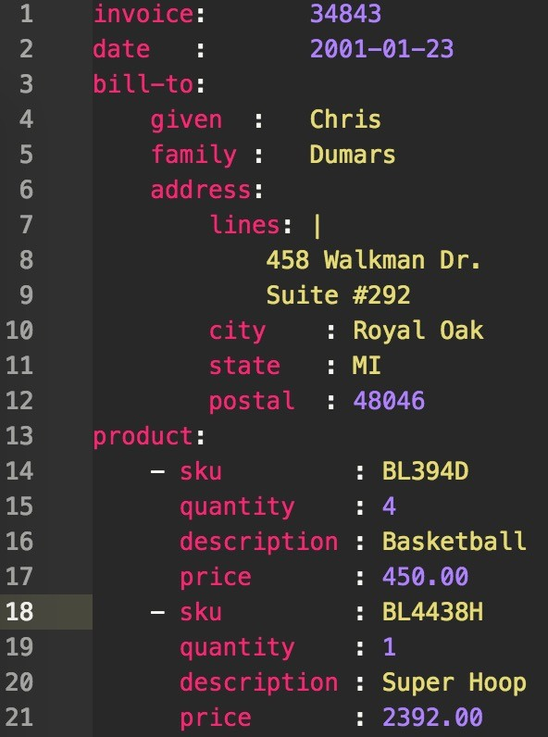YAML and JSON are the languages you can use for CloudFormation.
  + JSON is horrible for CF
  + YAML is great in so many ways
  + Let’s learn a bit about it!
  + Key value Pairs
  + Nested objects
  + Support Arrays
  + Multi line strings
  + Can include comments!

## What are resources?

* Resources are the core of your CloudFormation template (MANDATORY)
* They represent the different AWS Components that will be created and configured
* Resources are declared and can reference each other
* AWS figures out creation, updates and deletes of resources for us
* There are over 224 types of resources (!)
* Resource types identifiers are of the form:

**AWS::aws-product-name::data-type-name**

## How do I find

resources documentation?

* I can’t teach you all of the 224 resources, but I can teach you how to learn how to use them.
* All the resources can be found here: <http://docs.aws.amazon.com/AWSCloudFormation/latest/UserGuide/aw> s-template-resource-type-ref.html
* Then, we just read the docs ☺
* Example here (for an EC2 instance): <http://docs.aws.amazon.com/AWSCloudFormation/latest/UserGuide/aw> s-properties-ec2-instance.html

## Analysis of CloudFormation Template

* Going back to the example of the introductory section, let’s learn why it was written this way.
* Relevant documentation can be found here:
  + <http://docs.aws.amazon.com/AWSCloudFormation/latest/UserGuide/aws-> properties-ec2-instance.html
  + <http://docs.aws.amazon.com/AWSCloudFormation/latest/UserGuide/aws-> properties-ec2-security-group.html
  + <http://docs.aws.amazon.com/AWSCloudFormation/latest/UserGuide/aws-> properties-ec2-eip.html

## FAQ for resources

* Can I create a dynamic amount of resources?
* No, you can’t. Everything in the CloudFormation template has to be declared.You can’t perform code generation there
* Is every AWS Service supported?
* Almost. Only a select few niches are not there yet
* You can work around that using AWS Lambda Custom Resources

## What are parameters?

* Parameters are a way to provide inputs to your AWS CloudFormation template
* They’re important to know about if:
  + You want to reuse your templates across the company
  + Some inputs can not be determined ahead of time
* Parameters are extremely powerful, controlled, and can prevent errors from happening in your templates thanks to types.

## When should you use a parameter?

* Ask yourself this:
  + Is this CloudFormation resource configuration likely to change in the future?
  + If so, make it a parameter.
* You won’t have to re-upload a template to change its content ☺

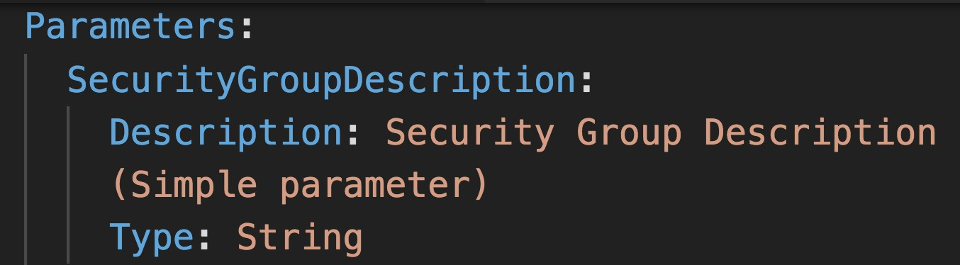

## Parameters Settings

Parameters can be controlled by all these settings:

* Type:
  + String
  + Number
  + CommaDelimitedList
  + List<Type>
  + AWS Parameter (to help catch invalid values – match against existing values in the AWS Account)
* Description
* Constraints
* ConstraintDescription (String)
* Min/MaxLength
* Min/MaxValue
* Defaults
* AllowedValues (array)
* AllowedPattern (regexp)
* NoEcho (Boolean)

©

## How to Reference a Parameter

* + The Fn::Ref function can be leveraged to reference parameters
  + Parameters can be used anywhere in a template.
  + The shorthand for this in YAML is !Ref
  + The function can also reference other elements within the template

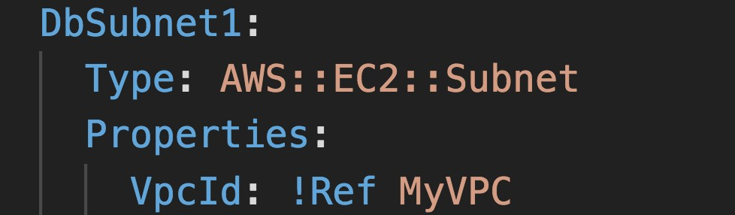

## Concept: Pseudo Parameters

* + AWS offers us pseudo parameters in any CloudFormation template.
  + These can be used at any time and are enabled by default

|  |  |
| --- | --- |
| **Reference Value** | **Example Return Value** |
| AWS::AccountId | 1234567890 |
| AWS::NotificationARNs | [arn:aws:sns:us-east- 1:123456789012:MyTopic] |
| AWS::NoValue | Does not return a value. |
| AWS::Region | us-east-2 |
| AWS::StackId | arn:aws:cloudformation:us-east- 1:123456789012:stack/MyStack/1c2fa62 0-982a-11e3-aff7-50e2416294e0 |
| AWS::StackName | MyStack |

## What are mappings?

* + Mappings are fixed variables within your CloudFormation Template.
  + They’re very handy to differentiate between different environments (dev vs prod), regions (AWS regions), AMI types, etc
  + All the values are hardcoded within the template
  + Example:

©

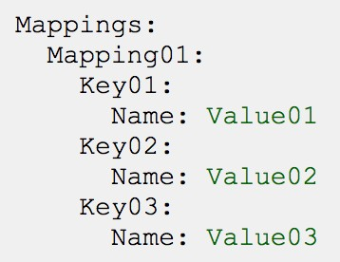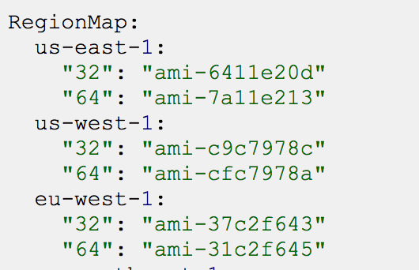

## When would you use mappings vs parameters ?

* + Mappings are great when you know in advance all the values that can be taken and that they can be deduced from variables such as
    - Region
    - Availability Zone
    - AWS Account
    - Environment (dev vs prod)
    - Etc…
  + They allow safer control over the template.
  + Use parameters when the values are really user specific

## Fn::FindInMap

Accessing Mapping Values

* + We use **Fn::FindInMap** to return a named value from a specific key
  + **!FindInMap [ *MapName*, *TopLevelKey*, *SecondLevelKey* ]**

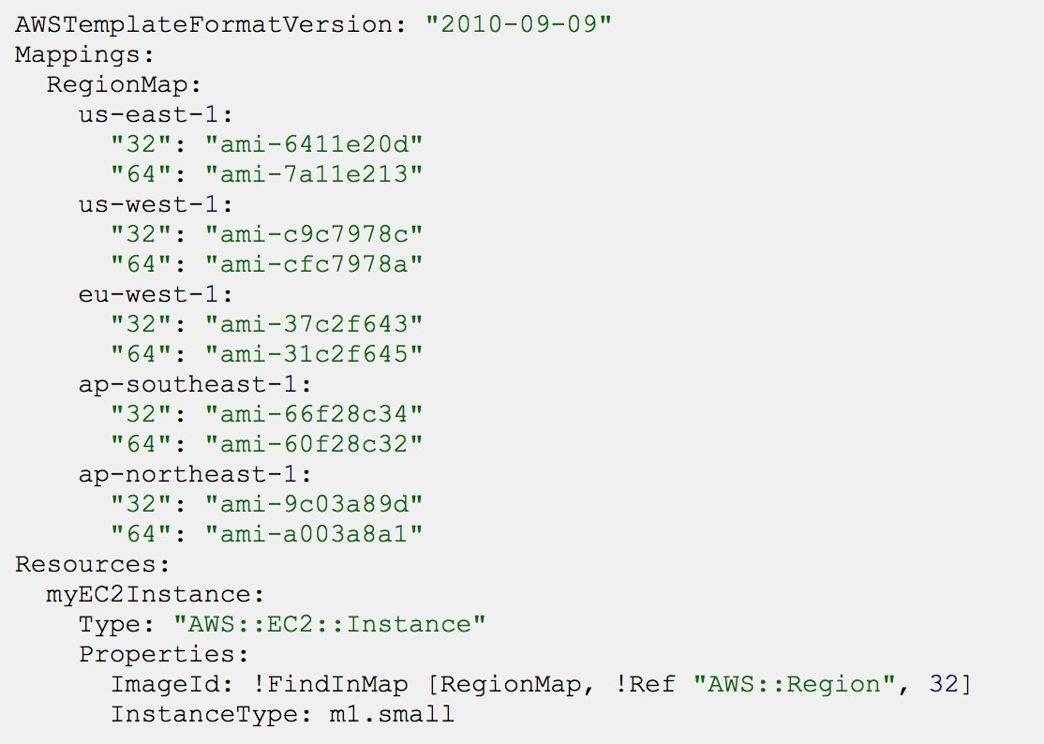

## What are outputs?

* + The Outputs section declares *optional* outputs values that we can import into other stacks (if you export them first)!
  + You can also view the outputs in the AWS Console or in using the AWS CLI
  + They’re very useful for example if you define a network CloudFormation, and output the variables such as VPC ID and your Subnet IDs
  + It’s the best way to perform some collaboration cross stack, as you let expert handle their own part of the stack
  + You can’t delete a CloudFormation Stack if its outputs are being referenced by another CloudFormation stack

## Outputs Example

* + Creating a SSH Security Group as part of one template
  + We create an output that references that security group

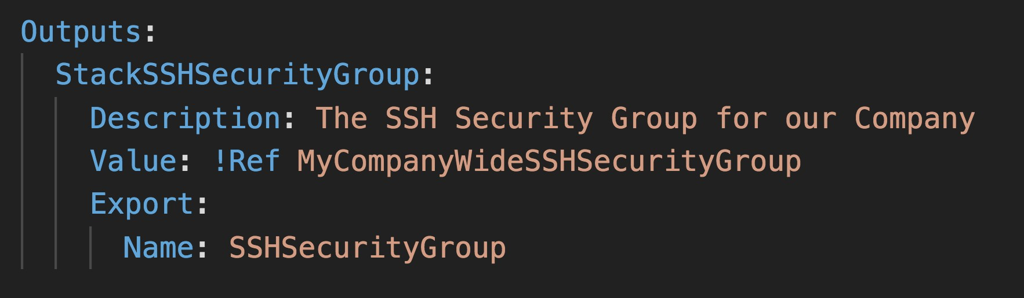

## Cross Stack Reference

* + We then create a second template that leverages that security group
  + For this, we use the **Fn::ImportValue** function
  + You can’t delete the underlying stack until all the references are deleted too.

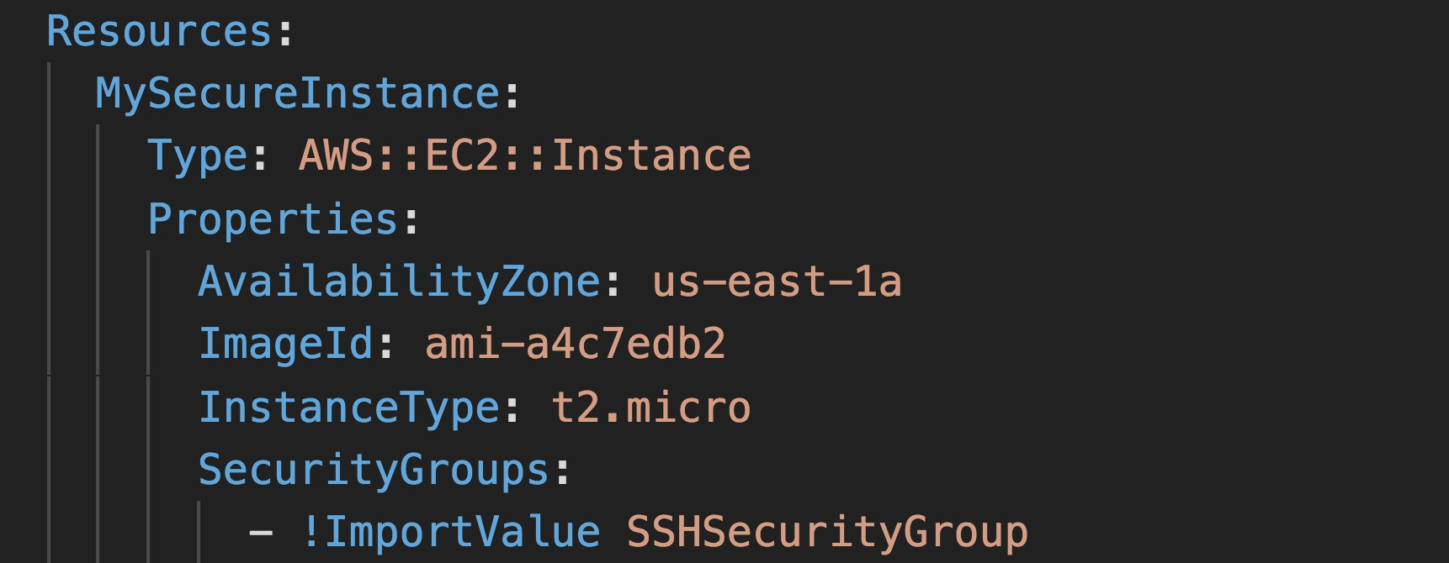

## What are conditions used for?

* + Conditions are used to control the creation of resources or outputs based on a condition.
  + Conditions can be whatever you want them to be, but common ones are:
    - Environment (dev / test / prod)
    - AWS Region
    - Any parameter value
  + Each condition can reference another condition, parameter value or mapping

## How to define a condition?

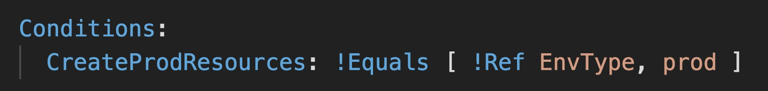

* + The logical ID is for you to choose. It’s how you name condition
  + The intrinsic function (logical) can be any of the following:
    - Fn::And
    - Fn::Equals
    - Fn::If
    - Fn::Not
    - Fn::Or

## Using a Condition

* + Conditions can be applied to resources / outputs / etc…

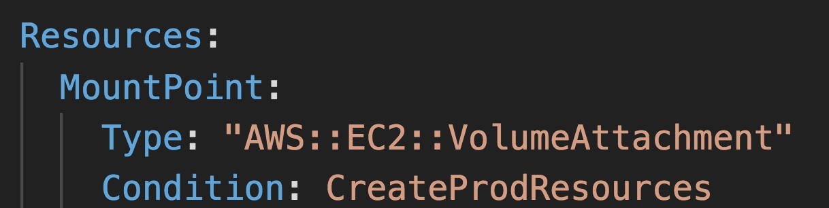

## CloudFormation

Must Know Intrinsic Functions

* + Ref
  + Fn::GetAtt
  + Fn::FindInMap
  + Fn::ImportValue
  + Fn::Join
  + Fn::Sub
  + Condition Functions (Fn::If, Fn::Not, Fn::Equals, etc…)

## Fn::Ref

* + The Fn::Ref function can be leveraged to reference
    - Parameters => returns the value of the parameter
    - Resources => returns the physical ID of the underlying resource (ex: EC2 ID)
  + The shorthand for this in YAML is !Ref



## Fn::GetAtt

* + Attributes are attached to any resources you create
  + To know the attributes of your resources, the best place to look at is the documentation.
  + For example: the AZ of an EC2 machine!

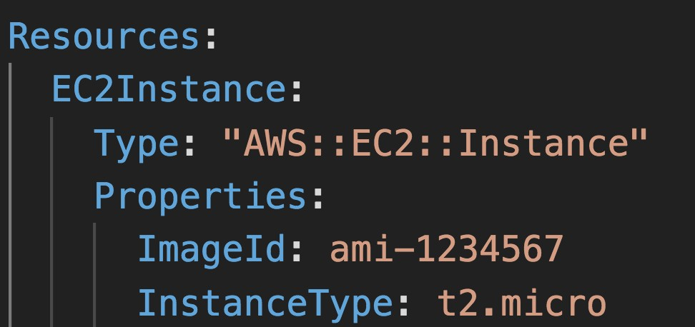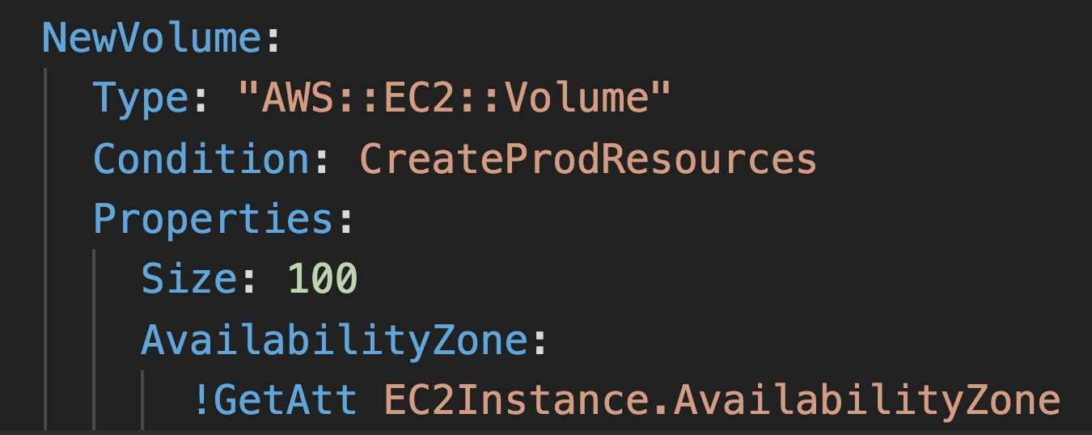

## Fn::FindInMap

Accessing Mapping Values

* + We use **Fn::FindInMap** to return a named value from a specific key
  + **!FindInMap [ *MapName*, *TopLevelKey*, *SecondLevelKey* ]**



## Fn::ImportValue

* + Import values that are exported in other templates
  + For this, we use the **Fn::ImportValue** function



## Fn::Join

* + Join values with a delimiter

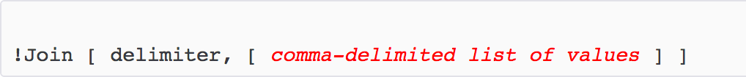

* + This creates “a:b:c”

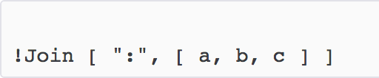

## Function Fn::Sub

* + Fn::Sub, or !Sub as a shorthand, is used to substitute variables from a text. It’s a very handy function that will allow you to fully customize your templates.
  + For example, you can combine Fn::Sub with References or AWS Pseudo variables!
  + String must contain ${VariableName} and will substitute them

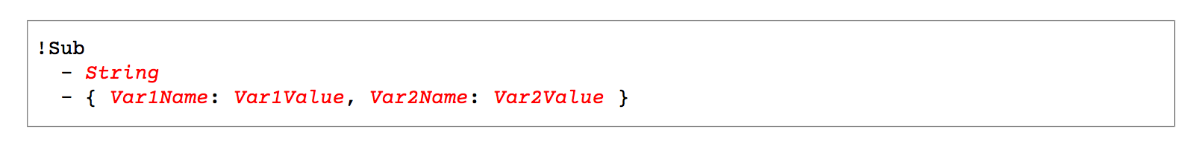



## Condition Functions



* + The logical ID is for you to choose. It’s how you name condition
  + The intrinsic function (logical) can be any of the following:
    - Fn::And
    - Fn::Equals
    - Fn::If
    - Fn::Not
    - Fn::Or

## CloudFormation Rollbacks

* + Stack Creation Fails:
    - Default: everything rolls back (gets deleted). We can look at the log
    - Option to disable rollback and troubleshoot what happened
  + Stack Update Fails:
    - The stack automatically rolls back to the previous known working state
    - Ability to see in the log what happened and error messages

## ChangeSets

* + When you update a stack, you need to know what changes before it happens for greater confidence
  + ChangeSets won’t say if the update will be successful
  1. Create Change set
  2. View Change set

1. Execute Change set

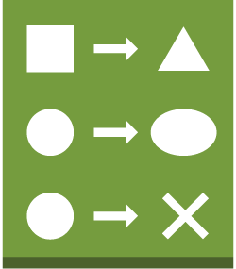**Original stack**

**change set change set**

**AWS CloudFormation**

3. (optional) Create Additional change sets

## Nested stacks

* + Nested stacks are stacks as part of other stacks
  + They allow you to isolate repeated patterns / common components in separate stacks and call them from other stacks
  + Example:
    - Load Balancer configuration that is re-used
    - Security Group that is re-used
  + Nested stacks are considered best practice
  + To update a nested stack, always update the parent (root stack)

## CloudFormation – Cross vs Nested Stacks

* + Cross Stacks

Stack

VPC

Stack 3

Stack 2

Stack 1

* + - Helpful when stacks have different lifecycles
    - Use Outputs Export and Fn::ImportValue
    - When you need to pass export values to many stacks (VPC Id, etc…)
  + Nested Stacks
    - Helpful when components must be re-used

|  |  |  |  |  |  |  |  |  |  |  |
| --- | --- | --- | --- | --- | --- | --- | --- | --- | --- | --- |
| App Stack | | | |  |  | App Stack | |  |  |  |
|  | RDS |  |  |  |  |  | RDS |  |  |
|  | Stack |  |  |  |  |  | Stack |  |  |
|  |  |  |  |  |  |  |  |  |  |
|
|  | ASG |  | ELB |  |  |  | ASG |  | ELB |
|  | Stack |  | Stack |  |  |  | Stack |  | Stack |  |
|  |  |  |  |  |  |  |  |  |  |  |
|

* + - Ex: re-use how to properly configure an Application Load Balancer
    - The nested stack only is important to the higher level stack (it’s not shared)

## CloudFormation - StackSets

* + Create, update, or delete stacks across multiple accounts and regions with a single operation
  + Administrator account to create StackSets
  + Trusted accounts to create, update, delete stack instances from StackSets
  + When you update a stack

set, *all* associated stack instances are

CloudFormation **StackSet**

Admin Account

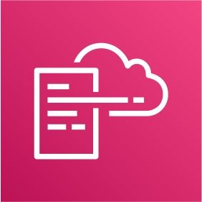

updated throughout all accounts and regions.

Account A Account A Account B us-east-1 ap-south-1 eu-west-2

## CloudFormation Drift

* + CloudFormation allows you to create infrastructure
  + But it doesn’t protect you against manual configuration changes
  + How do we know if our resources have drifted?
  + We can use CloudFormation drift!
  + Not all resources are supported yet: https://docs.aws.amazon.com/AWSCloudFormation/latest/UserGuide/usi ng-cfn-stack-drift-resource-list.html

# AWS Monitoring,Troubleshooting & Audit

CloudWatch, X-Ray and CloudTrail

## Why Monitoring is Important

* + We know how to deploy applications
    - Safely
    - Automatically
    - Using Infrastructure as Code
    - Leveraging the best AWS components!
  + Our applications are deployed, and our users don’t care how we did it…
  + Our users only care that the application is working!
    - Application latency: will it increase over time?
    - Application outages: customer experience should not be degraded
    - Users contacting the IT department or complaining is not a good outcome
    - Troubleshooting and remediation
  + Internal monitoring:
    - Can we prevent issues before they happen?
    - Performance and Cost
    - Trends (scaling patterns)
    - Learning and Improvement

## Monitoring in AWS

* + AWS CloudWatch:
    - Metrics: Collect and track key metrics
    - Logs: Collect, monitor, analyze and store log files
    - Events: Send notifications when certain events happen in your AWS
    - Alarms: React in real-time to metrics / events
  + AWS X-Ray:
    - Troubleshooting application performance and errors
    - Distributed tracing of microservices
  + AWS CloudTrail:
    - Internal monitoring of API calls being made
    - Audit changes to AWS Resources by your users

## AWS CloudWatch Metrics

* + CloudWatch provides metrics for *every* services in AWS
  + Metric is a variable to monitor (CPUUtilization, NetworkIn…)
  + Metrics belong to namespaces
  + Dimension is an attribute of a metric (instance id, environment, etc…).
  + Up to 10 dimensions per metric
  + Metrics have timestamps
  + Can create CloudWatch dashboards of metrics

## EC2 Detailed monitoring

* + EC2 instance metrics have metrics “every 5 minutes”
  + With detailed monitoring (for a cost), you get data “every 1 minute”
  + Use detailed monitoring if you want to scale faster for your ASG!
  + The AWS Free Tier allows us to have 10 detailed monitoring metrics
  + Note: EC2 Memory usage is by default not pushed (must be pushed from inside the instance as a custom metric)

## CloudWatch Custom Metrics

* + Possibility to define and send your own custom metrics to CloudWatch
  + Example: memory (RAM) usage, disk space, number of logged in users …
  + Use API call PutMetricData
  + Ability to use dimensions (attributes) to segment metrics
    - Instance.id
    - Environment.name
  + Metric resolution (StorageResolution API parameter – two possible value):
    - Standard: 1 minute (60 seconds)
    - High Resolution: 1/5/10/30 second(s) – Higher cost
  + Important: Accepts metric data points two weeks in the past and two hours in the future (make sure to configure your EC2 instance time correctly)

## CloudWatch Logs

* + Log groups: arbitrary name, usually representing an application
  + Log stream: instances within application / log files / containers
  + Can define log expiration policies (never expire, 30 days, etc..)
  + CloudWatch Logs can send logs to:
    - Amazon S3 (exports)
    - Kinesis Data Streams
    - Kinesis Data Firehose
    - AWS Lambda
    - ElasticSearch

## CloudWatch Logs - Sources

* + SDK, CloudWatch Logs Agent, CloudWatch Unified Agent
  + Elastic Beanstalk: collection of logs from application
  + ECS: collection from containers
  + AWS Lambda: collection from function logs
  + VPC Flow Logs:VPC specific logs
  + API Gateway
  + CloudTrail based on filter
  + Route53: Log DNS queries

## CloudWatch Logs Metric Filter & Insights

* + CloudWatch Logs can use filter expressions
    - For example, find a specific IP inside of a log
    - Or count occurrences of “ERROR” in your logs
  + Metric filters can be used to trigger CloudWatch alarms
  + CloudWatch Logs Insights can be used to query logs and add queries to CloudWatch Dashboards

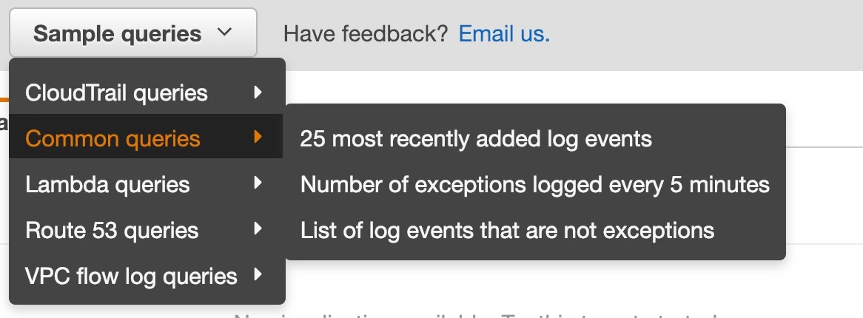

## CloudWatch Logs – S3 Export

* + - Log data can take up to 12 hours to become available for export



* + - The API call is CreateExportTask

CloudWatch Logs Amazon S3

* + Not near-real time or real-time… use Logs Subscriptions instead

## CloudWatch Logs Subscriptions

Lambda Function (managed by AWS)

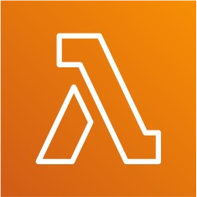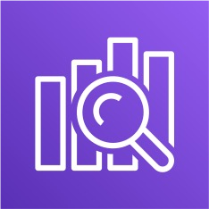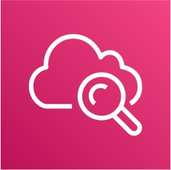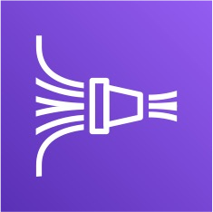

Real time

Amazon ES

Near

Real Time CloudWatch Logs **Subscription Filter** Kinesis Data Firehose

Amazon S3

Lambda Function (custom)

Kinesis Data Streams

KDF, KDA, EC2, Lambda…

## CloudWatch Logs Aggregation Multi-Account & Multi Region

**ACCOUNT A REGION 1**

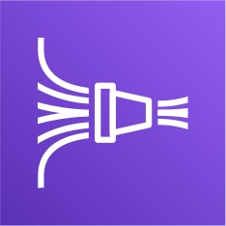

CloudWatch Logs Subscription Filter

**ACCOUNT B REGION 2**

CloudWatch Logs Subscription Filter

Near

Real Time Kinesis Data Streams Kinesis Data Firehose

Amazon S3

**ACCOUNT B REGION 3**

CloudWatch Logs Subscription Filter

## CloudWatch Logs for EC2

* + By default, no logs from your EC2 machine will go to CloudWatch

EC2 Instance

CloudWatch Logs Agent

CloudWatch Logs

* + You need to run a CloudWatch agent on EC2 to push the log files you want

On Premise Server

CloudWatch Logs Agent

* + Make sure IAM permissions are correct
  + The CloudWatch log agent can be setup on-premises too

## CloudWatch Logs Agent & Unified Agent

* + For virtual servers (EC2 instances, on-premise servers…)
  + CloudWatch Logs Agent
    - Old version of the agent
    - Can only send to CloudWatch Logs
  + CloudWatch Unified Agent
    - Collect additional system-level metrics such as RAM, processes, etc…
    - Collect logs to send to CloudWatch Logs
    - Centralized configuration using SSM Parameter Store

## CloudWatch Unified Agent – Metrics

* + Collected directly on your Linux server / EC2 instance
  + CPU (active, guest, idle, system, user, steal)
  + Disk metrics (free, used, total), Disk IO (writes, reads, bytes, iops)
  + RAM (free, inactive, used, total, cached)
  + Netstat (number of TCP and UDP connections, net packets, bytes)
  + Processes (total, dead, bloqued, idle, running, sleep)
  + Swap Space (free, used, used %)
  + Reminder: out-of-the box metrics for EC2 – disk, CPU, network (high level)

## CloudWatch Logs Metric Filter

* + CloudWatch Logs can use filter expressions
    - For example, find a specific IP inside of a log
    - Or count occurrences of “ERROR” in your logs
    - Metric filters can be used to trigger alarms
  + Filters do not retroactively filter data. Filters only publish the metric data points for events that happen after the filter was created.



stream

CloudWatch Logs Agent

EC2 Instance

CW Logs

Metric Filters CW Alarm SNS

## CloudWatch Alarms

* + Alarms are used to trigger notifications for any metric
  + Various options (sampling, %, max, min, etc…)
  + Alarm States:
    - OK
    - INSUFFICIENT_DATA
    - ALARM
  + Period:
    - Length of time in seconds to evaluate the metric
    - High resolution custom metrics: 10 sec, 30 sec or multiples of 60 sec

## CloudWatch Alarm Targets

* + Stop,Terminate, Reboot, or Recover an EC2 Instance
  + Trigger Auto Scaling Action
  + Send notification to SNS (from which you can do pretty much anything)



Amazon EC2 EC2 Auto Scaling Amazon SNS

## CloudWatch Alarms – Composite Alarms

* + CloudWatch Alarms are on a single metric
  + Composite Alarms are monitoring the states of multiple other alarms
  + AND and OR conditions
  + Helpful to reduce “alarm noise” by creating complex composite alarms

EC2 Instance



monitor **CPU**

monitor **IOPS**



trigger

**Composite Alarm**

ALARM

CW Alarm - **A**

ALARM

CW Alarm - **B**

Amazon SNS

## EC2 Instance Recovery

* + Status Check:
    - Instance status = check the EC2 VM
    - System status = check the underlying hardware

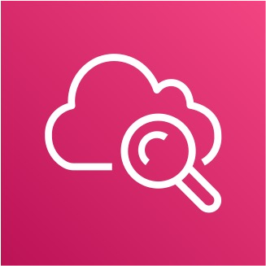

monitor

alert

EC2 Instance

CloudWatch Alarm

**StatusCheckFailed_System**

**SNS Topic**

EC2 Instance Recovery

* + Recovery: Same Private, Public, Elastic IP, metadata, placement group

## CloudWatch Alarm: good to know

* + Alarms can be created based on CloudWatch Logs Metrics Filters

Amazon SNS

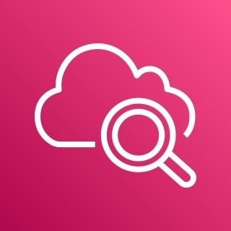

CloudWatch

**Metric Filter**

Alert

CW Logs

CW Alarm

* + To test alarms and notifications, set the alarm state to Alarm using CLI

aws cloudwatch set-alarm-state --alarm-name "myalarm" --state-value ALARM --state-reason "testing purposes"

## CloudWatch Events

* + Event Pattern: Intercept events from AWS services (Sources)
    - Example sources: EC2 Instance Start, CodeBuild Failure, S3,Trusted Advisor
    - Can intercept any API call with CloudTrail integration
  + Schedule or Cron (example: create an event every 4 hours)
  + A JSON payload is created from the event and passed to a target…
    - Compute: Lambda, Batch, ECS task
    - Integration: SQS, SNS, Kinesis Data Streams, Kinesis Data Firehose
    - Orchestration: Step Functions, CodePipeline, CodeBuild
    - Maintenance: SSM, EC2 Actions

## Amazon EventBridge

* + EventBridge is the next evolution of CloudWatch Events
  + Default Event Bus – generated by AWS services (CloudWatch Events)
  + Partner Event Bus – receive events from SaaS service or applications (Zendesk, DataDog, Segment, Auth0…)
  + Custom Event Buses – for your own applications
  + Event buses can be accessed by other AWS accounts
  + You can archive events (all/filter) sent to an event bus (indefinitely or set period)
  + Ability to replay archived events
  + Rules: how to process the events (like CloudWatch Events)

## Amazon EventBridge – Schema Registry

* + 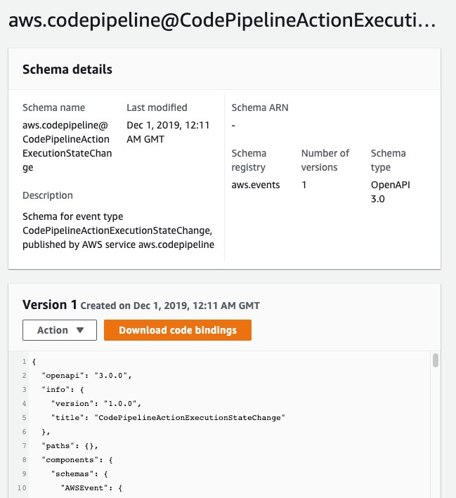EventBridge can analyze the events in your bus and infer the schema
  + The Schema Registry allows you to generate code for your application, that will know in advance how data is structured in the event bus
  + Schema can be versioned

## Amazon EventBridge – Resource-based Policy

* + Manage permissions for a specific Event Bus
  + Example: allow/deny events from another AWS account or AWS region
  + Use case: aggregate all events from your AWS Organization in a single AWS account or AWS region

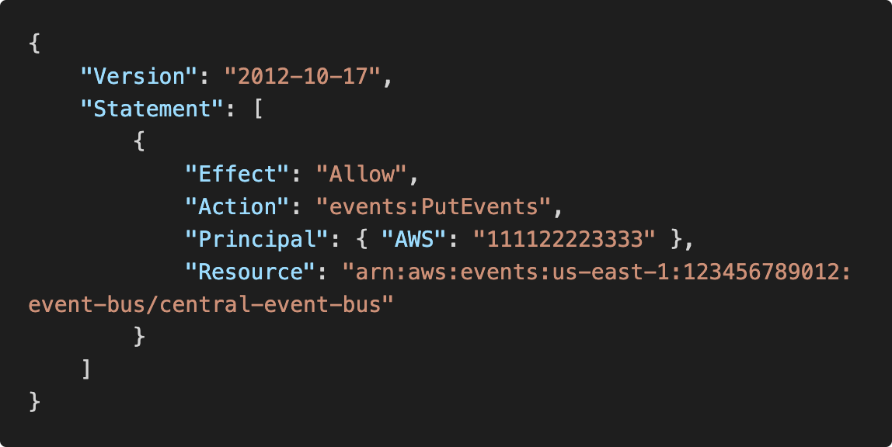

Allow **events** from another AWS account



AWS Account (123456789012)

AWS Account (111122223333)

PutEvents

EventBridge Bus

**(central-event-bus)**

Lambda function

## Amazon EventBridge vs CloudWatch Events

* Amazon EventBridge builds upon and extends CloudWatch Events.
* It uses the same service API and endpoint, and the same underlying service infrastructure.
* EventBridge allows extension to add event buses for your custom applications and your third-party SaaS apps.
* Event Bridge has the Schema Registry capability
* EventBridge has a different name to mark the new capabilities
* Over time, the CloudWatch Events name will be replaced with EventBridge.

## AWS X-Ray

* + Debugging in Production, the good old way:
    - Test locally
    - Add log statements everywhere
    - Re-deploy in production
  + Log formats differ across applications using CloudWatch and analytics is hard.
  + Debugging: monolith “easy”, distributed services “hard”
  + No common views of your entire architecture!
  + Enter… AWS X-Ray!

## AWS X-Ray

Visual analysis of our applications

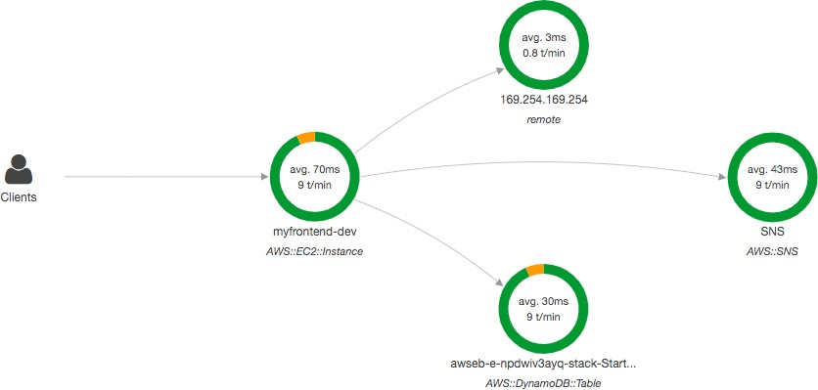

## AWS X-Ray advantages

* + Troubleshooting performance (bottlenecks)
  + Understand dependencies in a microservice architecture
  + Pinpoint service issues
  + Review request behavior
  + Find errors and exceptions
  + Are we meeting time SLA?
  + Where I am throttled?
  + Identify users that are impacted

## X-Ray compatibility

* + AWS Lambda
  + Elastic Beanstalk
  + ECS
  + ELB
  + API Gateway
  + EC2 Instances or any application server (even on premise)

## AWS X-Ray Leverages Tracing

* + Tracing is an end to end way to following a “request”
  + Each component dealing with the request adds its own “trace”
  + Tracing is made of segments (+ sub segments)
  + Annotations can be added to traces to provide extra-information
  + Ability to trace:
    - Every request
    - Sample request (as a % for example or a rate per minute)
  + X-Ray Security:
    - IAM for authorization
    - KMS for encryption at rest

## AWS X-Ray

EC2 Instance

Application Code

+ AWS X-Ray SDK

Send traces

X-Ray Daemon Running on machine

Send batch every 1 second to AWS X-Ray

How to enable it?

I) Your code (Java, Python, Go, Node.js, .NET) must import the AWS X-Ray SDK

* + Very little code modification needed
  + The application SDK will then capture:
* Calls to AWS services
  + - HTTP / HTTPS requests
    - Database Calls (MySQL, PostgreSQL, DynamoDB)
    - Queue calls (SQS)

2) Install the X-Ray daemon or enable X-Ray AWS Integration

* + X-Ray daemon works as a low level UDP packet interceptor (Linux / Windows / Mac…)
  + AWS Lambda / other AWS services already run the X-Ray

daemon for you

* + Each application must have the IAM rights to write data to X-Ray

©



## The X-Ray magic

* + X-Ray service collects data from all the different services
  + Service map is computed from all the segments and traces
  + X-Ray is graphical, so even non technical people can help troubleshoot



## AWS X-Ray Troubleshooting

* + If X-Ray is not working on EC2
    - Ensure the EC2 IAM Role has the proper permissions
    - Ensure the EC2 instance is running the X-Ray Daemon
  + To enable on AWS Lambda:
    - Ensure it has an IAM execution role with proper policy (AWSX-RayWriteOnlyAccess)
    - Ensure that X-Ray is imported in the code

## X-Ray Instrumentation in your code

* + Instrumentation means the

measure of product’s performance, diagnose errors, and to write trace information.

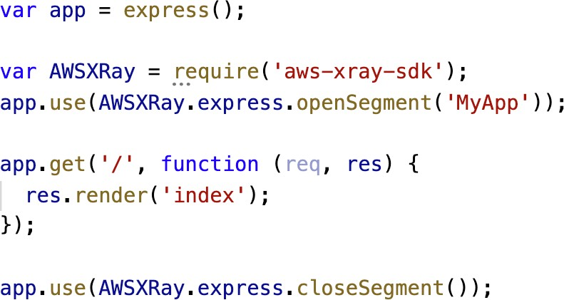

* + To instrument your application code, you use the X-Ray SDK
  + Many SDK require only configuration changes
  + You can modify your application code to customize and annotation the data that the SDK sends to X- Ray, using interceptors, filters, handlers, middleware…

**Example for Node.js & Express**

## X-Ray Concepts

* + Segments: each application / service will send them
  + Subsegments: if you need more details in your segment
  + Trace: segments collected together to form an end-to-end trace
  + Sampling: decrease the amount of requests sent to X-Ray, reduce cost
  + Annotations: Key Value pairs used to index traces and use with filters
  + Metadata: Key Value pairs, not indexed, not used for searching
  + The X-Ray daemon / agent has a config to send traces cross account:
    - make sure the IAM permissions are correct – the agent will assume the role
    - This allows to have a central account for all your application tracing

## X-Ray Sampling Rules

* + With sampling rules, you control the amount of data that you record
  + You can modify sampling rules without changing your code
  + By default, the X-Ray SDK records the first request each second, and

five percent of any additional requests.

* + One request per second is the *reservoir*, which ensures that at least one trace is recorded each second as long the service is serving requests.
  + Five percent is the *rate* at which additional requests beyond the reservoir size are sampled.

## X-Ray Custom Sampling Rules

* + You can create your own rules with the reservoir and rate

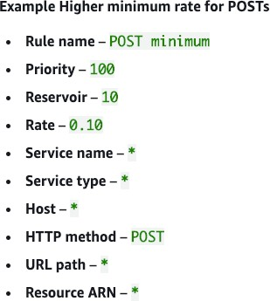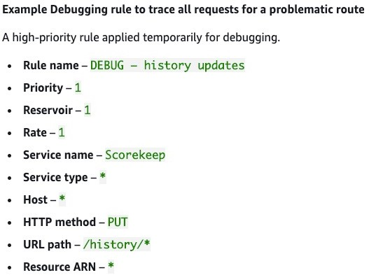

## X-Ray Write APIs (used by the X-Ray daemon)

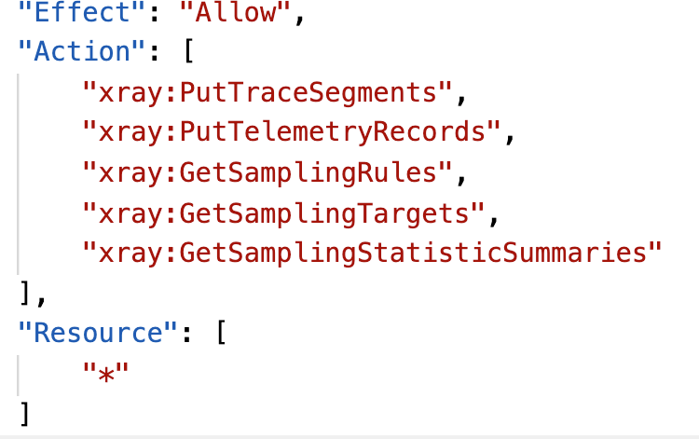

arn:aws:iam::aws:policy/AWSXrayWriteOnlyAccess

* PutTraceSegments: Uploads segment documents to AWS X-Ray
* PutTelemetryRecords: Used by the AWS X-Ray daemon to upload telemetry.
  + SegmentsReceivedCount, SegmentsRejectedCounts, BackendConnectionErrors…
* GetSamplingRules: Retrieve all sampling rules (to know what/when to send)
* GetSamplingTargets & GetSamplingStatisticSummaries: advanced
* The X-Ray daemon needs to have an IAM policy authorizing the correct API calls to function correctly

## Ray Read APIs – continued

* + GetServiceGraph: main graph

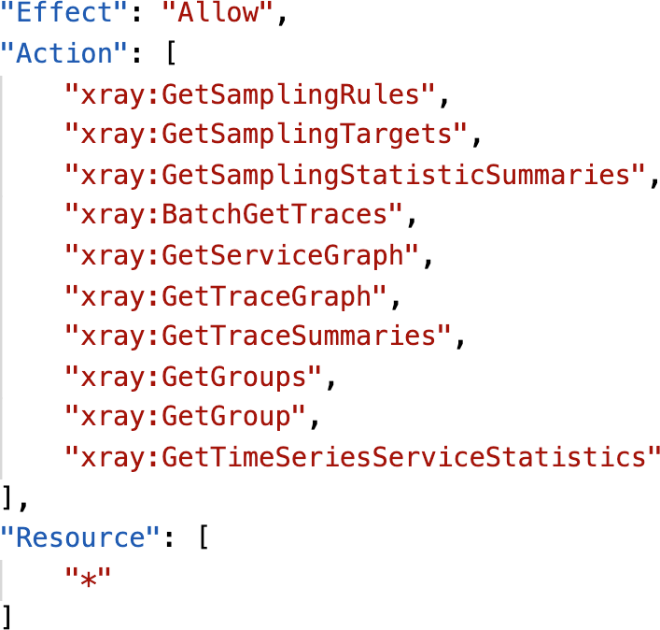

* + BatchGetTraces: Retrieves a list of traces specified by ID. Each trace is a collection of segment documents that originates from a single request.
  + GetTraceSummaries: Retrieves IDs and annotations for traces available for a specified time frame using an optional filter.To get the full traces, pass the trace IDs to BatchGetTraces.
  + GetTraceGraph: Retrieves a service graph for one or more specific trace IDs.

## X-Ray with Elastic Beanstalk ❤

* + AWS Elastic Beanstalk platforms include the X-Ray daemon
  + You can run the daemon by setting an option in the Elastic Beanstalk console or with a configuration file (in .ebextensions/xray-daemon.config)

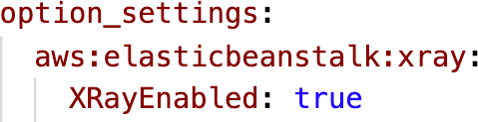

* + Make sure to give your instance profile the correct IAM permissions so that the X-Ray daemon can function correctly
  + Then make sure your application code is instrumented with the X-Ray SDK
  + Note:The X-Ray daemon is not provided for Multicontainer Docker

## ECS + X-Ray integration options



❤

ECS Cluster

X-Ray Container as a Daemon

ECS Cluster

X-Ray Container as a “Side Car”

Fargate Cluster

1. Ray Container as a “Side Car”

EC2

X-Ray Daemon Container

App Container

App Container

EC2

X-Ray Daemon Container

App Container

App Container

EC2

App Container

X-Ray Sidecar

App Container

X-Ray Sidecar

EC2

App Container

X-Ray Sidecar

App Container

X-Ray Sidecar

ECS Cluster

Fargate Task

App Container

X-Ray Sidecar

Fargate Task

App Container

X-Ray Sidecar

## ECS + X-Ray: Example Task Definition

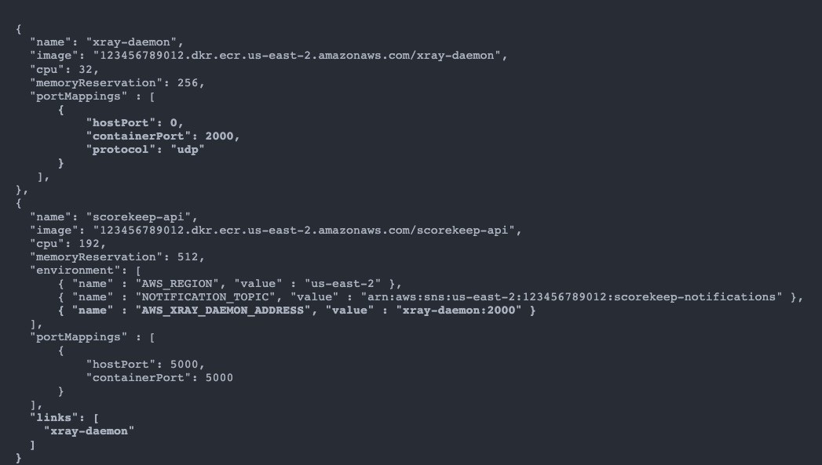

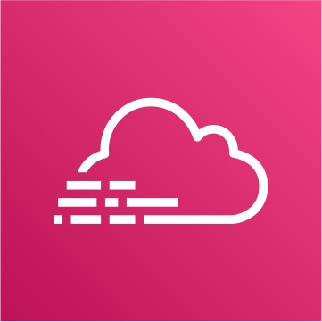AWS CloudTrail

* + Provides governance, compliance and audit for your AWS Account
  + CloudTrail is enabled by default!
  + Get an history of events / API calls made within your AWS Account by:
    - Console
    - SDK
    - CLI
    - AWS Services
  + Can put logs from CloudTrail into CloudWatch Logs or S3
  + A trail can be applied to All Regions (default) or a single Region.
  + If a resource is deleted in AWS, investigate CloudTrail first!

## CloudTrail Diagram



**SDK**

**CLI**



**CloudTrail Console**

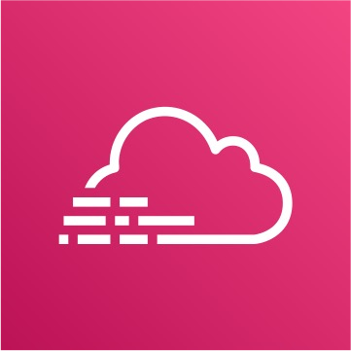

CloudWatch Logs



**Console**



**Inspect & Audit**



S3 Bucket



**IAM Users & IAM Roles**

## CloudTrail Events

* + Management Events:
    - Operations that are performed on resources in your AWS account
    - Examples:
      * Configuring security (IAM **AttachRolePolicy**)
      * Configuring rules for routing data (Amazon EC2 **CreateSubnet**)
      * Setting up logging (AWS CloudTrail **CreateTrail**)
    - By default, trails are configured to log management events.
    - Can separate Read Events (that don’t modify resources) from Write Events (that may modify resources)
  + Data Events:
    - By default, data events are not logged (because high volume operations)
    - Amazon S3 object-level activity (ex: **GetObject**, **DeleteObject**, **PutObject**): can separate Read and Write Events
    - AWS Lambda function execution activity (the **Invoke** API)
  + CloudTrail Insights Events:
    - See next slide ☺

## CloudTrail Insights

* + Enable CloudTrail Insights to detect unusual activity in your account:
    - inaccurate resource provisioning
    - hitting service limits
    - Bursts of AWS IAM actions
    - Gaps in periodic maintenance activity
  + CloudTrail Insights analyzes normal management events to create a baseline
  + And then continuously analyzes write events to detect unusual patterns
    - Anomalies appear in the CloudTrail console
    - Event is sent to Amazon S3
    - An EventBridge event is generated (for automation needs)

**CloudTrail Console**

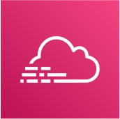

**Management Events**

Continous analysis

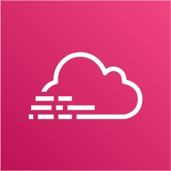

generate



**Insights Events**



**S3 Bucket**

**CloudTrail Insights**

**EventBridge event**



## CloudTrail Events Retention

* + Events are stored for 90 days in CloudTrail
  + To keep events beyond this period, log them to S3 and use Athena

**Management Events **

**Data Events **

**Insights Events**

**CloudTrail**

90 days

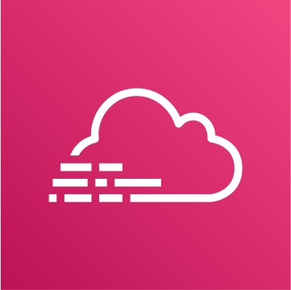

log

S3 Bucket

analyze

**Athena**

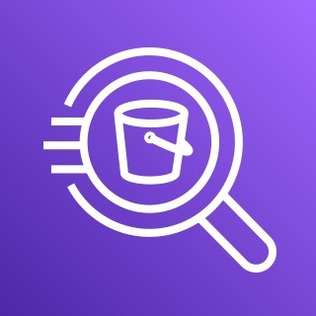

retention

Long-term retention

## CloudTrail vs CloudWatch vs X-Ray

* CloudTrail:
  + Audit API calls made by users / services / AWS console
  + Useful to detect unauthorized calls or root cause of changes
* CloudWatch:
  + CloudWatch Metrics over time for monitoring
  + CloudWatch Logs for storing application log
  + CloudWatch Alarms to send notifications in case of unexpected metrics
* X-Ray:
  + Automated Trace Analysis & Central Service Map Visualization
  + Latency, Errors and Fault analysis
  + Request tracking across distributed systems

# AWS Integration & Messaging

SQS, SNS & Kinesis

## Section Introduction

* When we start deploying multiple applications, they will inevitably need to communicate with one another
* There are two patterns of application communication

1. **Synchronous communications (application to application)**
2. **Asynchronous / Event based (application to queue to application)**

Buying Service

Shipping Service

Buying Service

Queue

Shipping Service

## Section Introduction

* Synchronous between applications can be problematic if there are sudden spikes of traffic
* What if you need to suddenly encode 1000 videos but usually it’s 10?
* In that case, it’s better to decouple your applications,
  + using SQS: queue model
  + using SNS: pub/sub model
  + using Kinesis: real-time streaming model
* These services can scale independently from our application!

## Amazon SQS What’s a queue?

SQS Queue

Send messages

Producer

Producer

Producer

Poll messages

Consumer

Consumer

Consumer

Consumer

## Amazon SQS – Standard Queue

* Oldest offering (over 10 years old)
* Fully managed service, used to decouple applications
* Attributes:
  + Unlimited throughput, unlimited number of messages in queue
  + Default retention of messages: 4 days, maximum of 14 days
  + Low latency (<10 ms on publish and receive)
  + Limitation of 256KB per message sent
* Can have duplicate messages (at least once delivery, occasionally)
* Can have out of order messages (best effort ordering)

## SQS – Producing Messages

* Produced to SQS using the SDK (SendMessage API)
* The message is persisted in SQS until a consumer deletes it
* Message retention: default 4 days, up to 14 days
* Example: send an order to be processed
  + Order id
  + Customer id
  + Any attributes you want
* SQS standard: unlimited throughput



Message

Up to 256 kb



Sent to SQS

## SQS – Consuming Messages

* Consumers (running on EC2 instances, servers, or AWS Lambda)…
* Poll SQS for messages (receive up to 10 messages at a time)
* Process the messages (example: insert the message into an RDS database)
* Delete the messages using the DeleteMessage API

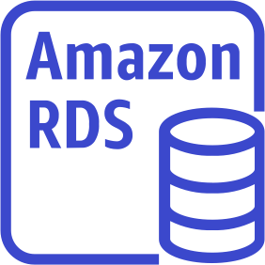

insert

Consumer



Poll / Receive messages

DeleteMessage

## SQS – Multiple EC2 Instances Consumers

* + Consumers receive and process messages in parallel



* + At least once delivery

SQS Queue

poll

* Best-effort message ordering
* Consumers delete messages after processing them
* We can scale consumers horizontally to improve throughput of processing

## SQS with Auto Scaling Group (ASG)

Poll for messages



**EC2 Instances**

**SQS Queue**

Alarm for breach

**Auto Scaling Group**

scale

**CloudWatch Metric – Queue Length**

ApproximateNumberOfMessages

**CloudWatch Alarm**

SQS to decouple between application tiers

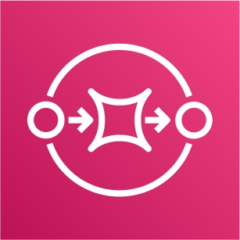

**Front-end web app**

requests

SendMessage

**Back-end processing Application**

**(video processing)**

ReceiveMessages

insert

**SQS Queue**

Auto-Scaling

Auto-Scaling

## Amazon SQS - Security

* Encryption:
  + In-flight encryption using HTTPS API
  + At-rest encryption using KMS keys
  + Client-side encryption if the client wants to perform encryption/decryption itself
* Access Controls: IAM policies to regulate access to the SQS API
* SQS Access Policies (similar to S3 bucket policies)
  + Useful for cross-account access to SQS queues
  + Useful for allowing other services (SNS, S3…) to write to an SQS queue

## SQS Queue Access Policy

Cross Account Access

Publish S3 Event Notifications To SQS Queue

Upload object  Send message S3 Bucket



Account 444455556666

Account 111122223333

Poll for messages

SQS Queue (queue1)

EC2 Instance

(bucket1)

{

SQS Queue (queue1)

{

"Version": "2012-10-17",

"Statement" : [{

"Effect": "Allow",

**"Principal": { "AWS": [ "111122223333" ] },**

"Action": [ "sqs:ReceiveMessage" ],

"Resource": "arn:aws:sqs:us-east-1:444455556666:queue1"

}]

"Version": "2012-10-17",

©

}

"Statement" : [{

"Effect": "Allow", "Principal": { "AWS": "*"},

"Action": [ "sqs:SendMessage" ],

"Resource": "arn:aws:sqs:us-east-1:444455556666:queue1",

**"Condition": {**

**"ArnLike": { "aws:SourceArn": "arn:aws:s3:*:*:bucket1" },**

**"StringEquals": { "aws:SourceAccount": "<bucket1_owner_account_id>" },**

}

}]

**}**

## SQS – Message Visibility Timeout

* After a message is polled by a consumer, it becomes invisible to other consumers
* By default, the “message visibility timeout” is 30 seconds
* That means the message has 30 seconds to be processed
* After the message visibility timeout is over, the message is “visible” in SQS

ReceiveMessage Request

ReceiveMessage Request

ReceiveMessage Request

ReceiveMessage Request

Message returned



Not returned

Not returned

**Time**

Visibility timeout

Message returned (again)

## SQS – Message Visibility Timeout

ReceiveMessage Request

ReceiveMessage Request

ReceiveMessage Request

ReceiveMessage Request

Message returned



Not returned

Not returned

**Time**

Visibility timeout

Message returned (again)

* + If a message is not processed within the visibility timeout, it will be processed twice
  + A consumer could call the ChangeMessageVisibility API to get more time
  + If visibility timeout is high (hours), and consumer crashes, re-processing will take time
  + If visibility timeout is too low (seconds), we may get duplicates

## Amazon SQS – FIFO Queue

* FIFO = First In First Out (ordering of messages in the queue)

Send messages Poll messages

Consumer

Producer

4

3

2

1

4

3

2

1

* Limited throughput: 300 msg/s without batching, 3000 msg/s with
* Exactly-once send capability (by removing duplicates)
* Messages are processed in order by the consumer

## Amazon SQS – Dead Letter Queue (DLQ)



**Queue**

* If a consumer fails to process a message within the Visibility Timeout…

the message goes back to the queue!

* We can set a threshold of how many times a message can go back to the queue
* After the MaximumReceives threshold is exceeded, the message goes into a Dead Letter Queue (DLQ)
* Useful for debugging!
* DLQ of a FIFO queue must also be a FIFO queue
* DLQ of a Standard queue must also be a Standard queue
* Make sure to process the messages in the DLQ before they expire:
  + Good to set a retention of 14 days in the DLQ

**SQS Queue**

Failure loop



Consumer

**Dead Letter**

## SQS DLQ – Redrive to Source

* Feature to help consume messages in the DLQ to understand what is wrong with them
* When our code is fixed, we can redrive the messages from the DLQ back into the source queue (or any other queue) in batches without writing custom code

**Source SQS Queue**

✅



**Dead Letter Queue**

Redrive task

Manual inspection And debugging

Consumer

## Amazon SQS – Delay Queue

* Delay a message (consumers don’t see it immediately) up to 15 minutes
* Default is 0 seconds (message is available right away)
* Can set a default at queue level
* Can override the default on send using the DelaySeconds parameter

Send messages Poll messages



Consumer

Producer

## Amazon SQS - Long Polling

Consumer

* When a consumer requests messages from the queue, it can optionally “wait” for messages to arrive if there are none in the queue
* This is called Long Polling
* LongPolling decreases the number of API calls made to SQS while increasing the efficiency and latency of your application.
* The wait time can be between 1 sec to 20 sec (20 sec preferable)
* Long Polling is preferable to Short Polling
* Long polling can be enabled at the queue level or at the API level using ReceiveMessageWaitTimeSeconds



poll

message

**SQS Queue**



## SQS Extended Client

* Message size limit is 256KB, how to send large messages, e.g. 1GB?
* Using the SQS Extended Client (Java Library)

**SQS Queue**



Producer

Small metadata message

Consumer

Small metadata message

**Send large message to S3 Retrieve large message from S3**

**Amazon S3 bucket**

## SQS – Must know API

* CreateQueue (MessageRetentionPeriod), DeleteQueue
* PurgeQueue: delete all the messages in queue
* SendMessage (DelaySeconds), ReceiveMessage, DeleteMessage
* MaxNumberOfMessages: default 1, max 10 (for ReceiveMessage API)
* ReceiveMessageWaitTimeSeconds: Long Polling
* ChangeMessageVisibility: change the message timeout
* Batch APIs for SendMessage, DeleteMessage, ChangeMessageVisibility

helps decrease your costs

## SQS FIFO – Deduplication

* De-duplication interval is 5 minutes
* Two de-duplication methods:
  + Content-based deduplication: will do a SHA-256 hash of the message body
  + Explicitly provide a Message Deduplication ID

 Hello world Hello world

Producer

SHA-256:

b94d27b9934d3e08a52e52d7da7dabfa c484efe37a5380ee9088f7ace2efcde9



## SQS FIFO – Message Grouping

C2

C1

Consumer for Group “C”

* If you specify the same value of MessageGroupID in an SQS FIFO queue, you can only have one consumer, and all the messages are in order
* To get ordering at the level of a subset of messages, specify different values for MessageGroupID
  + Messages that share a common Message Group ID will be in order within the group
  + Each Group ID can have a different consumer (parallel processing!)
  + Ordering across groups is not guaranteed

B4

B3

B2

B1

Consumer for Group “B”



SQS FIFO

A3

A2

A1

Consumer for Group “A”

## Kinesis Overview

* Makes it easy to collect, process, and analyze streaming data in real-time
* Ingest real-time data such as: Application logs, Metrics, Website clickstreams, IoT telemetry data…

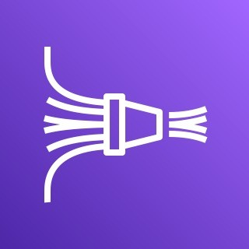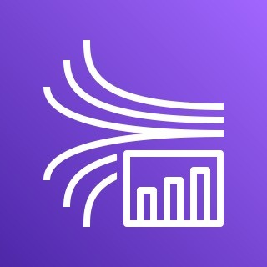

* Kinesis Data Streams: capture, process, and store data streams
* Kinesis Data Firehose: load data streams into AWS data stores
* Kinesis Data Analytics: analyze data streams with SQL or Apache Flink
* Kinesis Video Streams: capture, process, and store video streams

## Kinesis Data Streams

Record



Data Blob (up to 1 MB)

Partition Key

Shard N

Shard 2

Shard 1



Applications  Client

SDK, KPL 

Kinesis Agent

**Producers**



1 MB/sec

or 1000 msg/sec per shard



Stream

**Kinesis Data Streams**

Record

Can scale # of shards

|  |
| --- |
| Partition Key |
| Sequence no. |
| Data Blob |

2 MB/sec (shared) Per shard all consumers



 Apps (KCL, SDK)

Lambda

Kinesis Data Firehose

Kinesis Data Analytics

**Consumers**

OR

2 MB/sec (enhanced) Per shard per consumer

## Kinesis Data Streams

* Retention between 1 day to 365 days
* Ability to reprocess (replay) data
* Once data is inserted in Kinesis, it can’t be deleted (immutability)
* Data that shares the same partition goes to the same shard (ordering)
* Producers: AWS SDK, Kinesis Producer Library (KPL), Kinesis Agent
* Consumers:
  + Write your own: Kinesis Client Library (KCL), AWS SDK
  + Managed: AWS Lambda, Kinesis Data Firehose, Kinesis Data Analytics,

## Kinesis Data Streams – Capacity Modes

* Provisioned mode:
  + You choose the number of shards provisioned, scale manually or using API
  + Each shard gets 1MB/s in (or 1000 records per second)
  + Each shard gets 2MB/s out (classic or enhanced fan-out consumer)
  + You pay per shard provisioned per hour
* On-demand mode:
  + No need to provision or manage the capacity
  + Default capacity provisioned (4 MB/s in or 4000 records per second)
  + Scales automatically based on observed throughput peak during the last 30 days
  + Pay per stream per hour & data in/out per GB

## Kinesis Data Streams Security

* Control access / authorization using IAM policies



Region

VPC

Private subnet

HTTPS

HTTPS

EC2 Instance VPC Endpoint

Stream

**Kinesis Data Stream**

Encryption at rest

Shard 3

Shard 2

Shard 1

* Encryption in flight using HTTPS endpoints
* Encryption at rest using KMS
* You can implement encryption/decryption of data on client side (harder)
* VPC Endpoints available for Kinesis to access within VPC
* Monitor API calls using CloudTrail

## Kinesis Producers

* Puts data records into data streams
* Data record consists of:
  + Sequence number (unique per partition-key within shard)
  + Partition key (must specify while put records into stream)
  + Data blob (up to 1 MB)
* Producers:
  + AWS SDK: simple producer
  + Kinesis Producer Library (KPL): C++, Java, batch, compression, retries
  + Kinesis Agent: monitor log files
* Write throughput: 1 MB/sec or 1000 records/sec per shard
* PutRecord API
* Use batching with PutRecords API to reduce costs & increase throughput

## Kinesis Producers



Partition Key = Device Id

111222333

Same partition key = Same shard

111222333

444555666

1 MB/sec

or 1000 records/sec per shard

Stream

**Kinesis Data Streams**

Data Blob (up to 1 MB)

444555666

Data Blob (up to 1 MB)

Hash function

Shard N

Shard 2

Shard 1



Device Id 111222333

Device Id 444555666

**IoT Devices**

Use highly distributed partition key to avoid “hot partition”

## Kinesis - ProvisionedThroughputExceeded

1 MB/sec or 1000 records/sec



Applications  Client

SDK, KPL 

Kinesis Agent

**Producers**



Shard 1

Shard 2

2 MB/sec

Shard N

Solution:

ProvisionedThroughputExceeded

Stream

* + Use highly distributed partition key
  + Retries with exponential backoff
  + Increase shards (scaling)

**Kinesis Data Streams**

## Kinesis Data Streams Consumers

* Get data records from data streams and process them
* AWS Lambda
* Kinesis Data Analytics
* Kinesis Data Firehose
* Custom Consumer (AWS SDK) – Classic or Enhanced Fan-Out
* Kinesis Client Library (KCL): library to simplify reading from data stream

## Kinesis Consumers – Custom Consumer

Shared (Classic) Fan-out Consumer Enhanced Fan-out Consumer

2 MB/sec per shard across all consumers



Consumer Application A

Consumer Application A

Shard 2

Shard 1

Shard 2

2 MB/sec per consumer per shard



Shard 1



Shard N

Consumer Application C

Shard N

Consumer Application C

Stream

Consumer Application B

Consumer Application B

**Kinesis Data Streams**

Stream

**Kinesis Data Streams**

## Kinesis Consumers Types

Shared (Classic) Fan-out Consumer - pull Enhanced Fan-out Consumer - push

* Low number of consuming applications
* Read throughput: 2 MB/sec per shard across all consumers
* Max. 5 GetRecords API calls/sec
* Latency ~200 ms
* Minimize cost ($)
* Consumers poll data from Kinesis using GetRecords API call
* Returns up to 10 MB (then throttle for 5 seconds) or up to 10000 records
* Multiple consuming applications for the same stream
* 2 MB/sec per consumer per shard
* Latency ~70 ms
* Higher costs ($$$)
* Kinesis pushes data to consumers over HTTP/2 (SubscribeToShard API)
* Soft limit of 5 consumer applications (KCL) per data stream (default)

## Kinesis Consumers – AWS Lambda

* + Supports Classic & Enhanced fan-out consumers

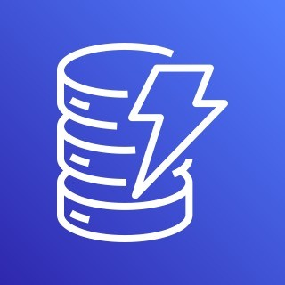

Lambda functions

(process records & save to DynamoDB)

GetBatch() 1 1

2

3

Amazon DynamoDB

Stream

**Kinesis Data Streams**

Shard N

Shard 2

3 1 2 1

* + Read records in batches
  + Can configure batch size and

batch window

* + If error occurs, Lambda retries until succeeds or data expired
  + Can process up to 10 batches per shard simultaneously

## Kinesis Client Library (KCL)

* + A Java library that helps read record from a Kinesis Data Stream with distributed applications sharing the read workload
  + Each shard is to be read by only one KCL instance
    - 4 shards = max. 4 KCL instances
    - 6 shards = max. 6 KCL instances
  + Progress is checkpointed into DynamoDB (needs IAM access)
  + Track other workers and share the work amongst shards using DynamoDB
  + KCL can run on EC2, Elastic Beanstalk, and on-premises
  + Records are read in order at the shard level
  + Versions:
    - KCL 1.x (supports shared consumer)
    - KCL 2.x (supports shared & enhanced fan-out consumer)

## KCL Example: 4 shards

KCL app Running on EC2



Shard 4

Shard 3

Shard 2

Shard 1

Checkpointing progress

Stream

**Kinesis Data Streams**

KCL app Running on EC2

Amazon DynamoDB

## KCL Example: 4 shards, Scaling KCL App

DynamoDB



KCL app Running on EC2

KCL app Running on EC2

KCL app Running on EC2

Stream

**Kinesis Data Streams**

KCL app Running on EC2

Amazon

Shard 4

Shard 3

Shard 2

Shard 1

Checkpointing progress

KCL Example: 6 shards, Scaling Kinesis



Shard 1

KCL app Running on EC2



KCL app Running on EC2

Shard 4

Shard 3

Shard 2

Checkpointing progress



KCL app Running on EC2

Shard 5



Stream

Shard 6

**Kinesis Data Streams**

KCL app Running on EC2

Amazon DynamoDB

©

## KCL Example: 6 shards, Scaling KCL App



Shard 1



Shard 5

Shard 6

Stream

**Kinesis Data Streams**



Amazon DynamoDB

Shard 4

Shard 3

Shard 2

Checkpointing progress

## Kinesis Operation – Shard Splitting

* + Used to increase the Stream capacity (1 MB/s data in per shard)



Split

Stream

**Kinesis Data Stream**

Stream

**Kinesis Data Stream**

Shard 3

Shard 2

Shard 1

Shard 3

Shard 5 (new)

Shard 4 (new)

Shard 1

* + Used to divide a “hot shard”
  + The old shard is closed and will be deleted once the data is expired
  + No automatic scaling (manually increase/decrease capacity)
  + Can’t split into more than two shards in a single operation

**Increase** capacity and cost

## Kinesis Operation – Merging Shards

* + Decrease the Stream capacity and save costs



Merge

Stream

**Kinesis Data Stream**

Stream

**Kinesis Data Stream**

Shard 3

Shard 5

Shard 6

Shard 3

Shard 5

Shard 4

Shard 1

* + Can be used to group two shards with low traffic (cold shards)
  + Old shards are closed and will be deleted once the data is expired
  + Can’t merge more than two shards in a single operation

©

**Decrease** capacity and cost

## Kinesis Data Firehose

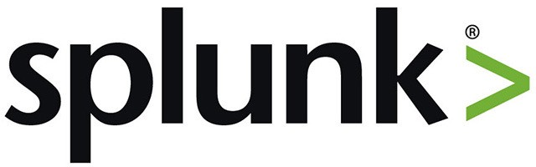

**3rd-party Partner Destinations**

Datadog

Lambda function

Applications



Data transformation

Kinesis Data Streams



**AWS Destinations**

Amazon S3

Amazon Redshift (COPY through S3)

Amazon OpenSearch

Record

Client



Up to 1 MB

Batch writes

Amazon CloudWatch (Logs & Events)

SDK, KPL

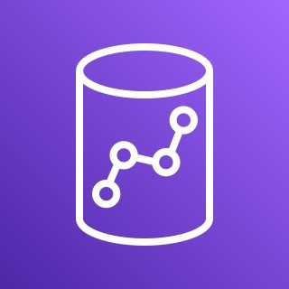

Kinesis



Data Firehose



*All or Failed data*

Kinesis Agent



**Custom Destinations**

**HTTP Endpoint**

AWS IoT

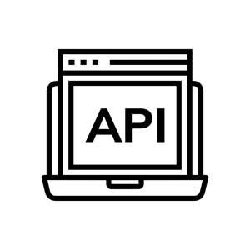

S3 backup bucket

**Producers**

## Kinesis Data Firehose

* + Fully Managed Service, no administration, automatic scaling, serverless
    - AWS: Redshift / Amazon S3 / OpenSearch
    - 3rd party partner: Splunk / MongoDB / DataDog / NewRelic / …
    - Custom: send to any HTTP endpoint
  + Pay for data going through Firehose
  + Near Real Time
    - 60 seconds latency minimum for non full batches
    - Or minimum 1 MB of data at a time
  + Supports many data formats, conversions, transformations, compression
  + Supports custom data transformations using AWS Lambda
  + Can send failed or all data to a backup S3 bucket

## Kinesis Data Streams vs Firehose

Kinesis Data Streams Kinesis Data Firehose

* + Streaming service for ingest at scale
  + Write custom code (producer / consumer)
  + Real-time (~200 ms)
  + Manage scaling (shard splitting / merging)
  + Data storage for 1 to 365 days
  + Supports replay capability
* Load streaming data into S3 / Redshift / ES / 3rd party / custom HTTP
* Fully managed
* Near real-time (buffer time min. 60 sec)
* Automatic scaling
* No data storage
* Doesn’t support replay capability

©

## Kinesis Data Analytics for SQL applications

**Kinesis Data Streams**





Kinesis Data Streams

Kinesis Data Firehose

**Sources**

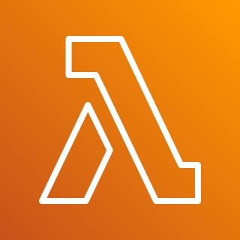

SQL

Statements

AWS Lambda

Applications

*anywhere*

*anywhere*

**Kinesis Data Analytics**

**for SQL Applications**

**Kinesis Data Firehose**

©

**Reference Data in S3**

Amazon S3

Amazon Redshift (COPY through S3)

*Other Firehose destinations…*

**Sinks**

## Kinesis Data Analytics (SQL application)

* + Real-time analytics on Kinesis Data Streams & Firehose using SQL
  + Add reference data from Amazon S3 to enrich streaming data
  + Fully managed, no servers to provision
  + Automatic scaling
  + Pay for actual consumption rate
  + Output:
    - Kinesis Data Streams: create streams out of the real-time analytics queries
    - Kinesis Data Firehose: send analytics query results to destinations
  + Use cases:
    - Time-series analytics
    - Real-time dashboards
    - Real-time metrics

## Kinesis Data Analytics for Apache Flink

* + Use Flink (Java, Scala or SQL) to process and analyze streaming data

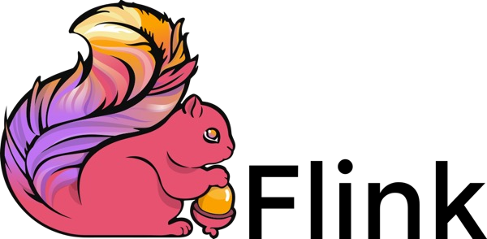Kinesis Data Streams

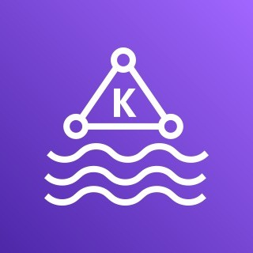Amazon MSK Kinesis Data Analytics

For Apache Flink

* + Run any Apache Flink application on a managed cluster on AWS
    - provisioning compute resources, parallel computation, automatic scaling
    - application backups (implemented as checkpoints and snapshots)
    - Use any Apache Flink programming features
    - Flink does not read from Firehose (use Kinesis Analytics for SQL instead)

## Ordering data into Kinesis

* + Imagine you have 100 trucks (truck_1, truck_2, … truck_100) on the road sending their GPS positions regularly into AWS.



1

**Kinesis Stream with 3 Shards**

2

Shard 1

3

Shard 2

4

Shard 3

5

Partition Key is “truck_id”

* + You want to consume the data in order for each truck, so that you can track their movement accurately.
  + How should you send that data into Kinesis?
  + Answer: send using a “Partition Key”

value of the “truck_id”

* + The same key will always go to the same shard

## Ordering data into SQS

* + - For SQS standard, there is no ordering.
    - For SQS FIFO, if you don’t use a Group ID, messages are consumed in the order they are sent, with only one consumer

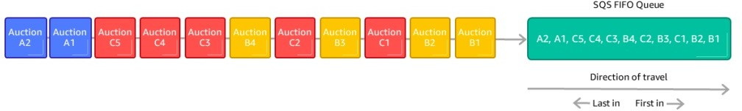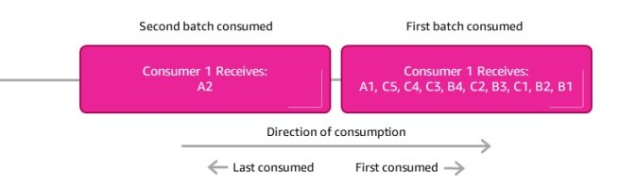

* + - You want to scale the number of consumers, but you want messages to be “grouped” when they are related to each other
    - Then you use a Group ID (similar to Partition Key in Kinesis)

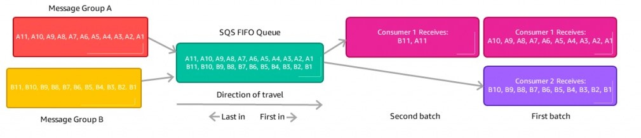

## Kinesis vs SQS ordering

* + Let’s assume 100 trucks, 5 kinesis shards, 1 SQS FIFO
  + Kinesis Data Streams:
    - On average you’ll have 20 trucks per shard
    - Trucks will have their data ordered within each shard
    - The maximum amount of consumers in parallel we can have is 5
    - Can receive up to 5 MB/s of data
  + SQS FIFO
    - You only have one SQS FIFO queue
    - You will have 100 Group ID
    - You can have up to 100 Consumers (due to the 100 Group ID)
    - You have up to 300 messages per second (or 3000 if using batching)

## Amazon SNS

* + What if you want to send one message to many receivers?



**SNS Topic**

SQS Queue

Shipping Service

Buying Service

Fraud Service

Email notification

**Direct integration**

SQS Queue

Shipping Service

Buying Service

Fraud Service

Email notification

**Pub / Sub**

## Amazon SNS

* + The “event producer” only sends message to one SNS topic
  + As many “event receivers” (subscriptions) as we want to listen to the SNS topic notifications
  + Each subscriber to the topic will get all the messages (note: new feature to filter messages)
  + Up to 12,500,000 subscriptions per topic
  + 100,000 topics limit

Subscribers

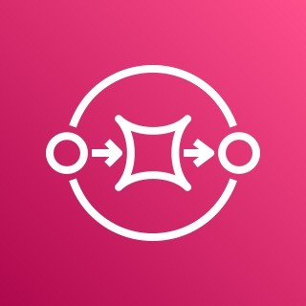

publish

Kinesis Data Firehose

Lambda

SQS



SNS

Emails

SMS &

Mobile Notifications

HTTP(S)

Endpoints

## SNS integrates with a lot of AWS services

* + Many AWS services can send data directly to SNS for notifications

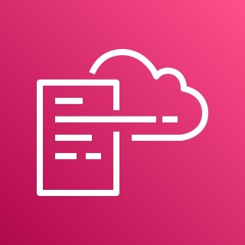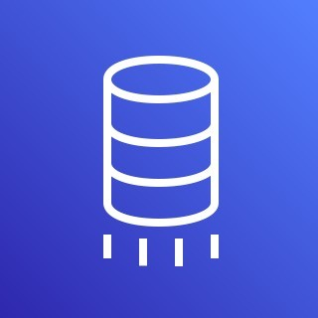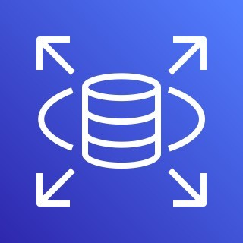

…

CloudWatch Alarms AWS Budgets

Lambda

…

Auto Scaling Group (Notifications)

S3 Bucket (Events)

DynamoDB

…

CloudFormation (State Changes)

AWS DMS

(New Replic)

RDS Events

publish

SNS

## Amazon SNS – How to publish

* + Topic Publish (using the SDK)
    - Create a topic
    - Create a subscription (or many)
    - Publish to the topic
  + Direct Publish (for mobile apps SDK)
    - Create a platform application
    - Create a platform endpoint
    - Publish to the platform endpoint
    - Works with Google GCM, Apple APNS, Amazon ADM…

## Amazon SNS – Security

* + Encryption:
    - In-flight encryption using HTTPS API
    - At-rest encryption using KMS keys
    - Client-side encryption if the client wants to perform encryption/decryption itself
  + Access Controls: IAM policies to regulate access to the SNS API
  + SNS Access Policies (similar to S3 bucket policies)
    - Useful for cross-account access to SNS topics
    - Useful for allowing other services ( S3…) to write to an SNS topic

## SNS + SQS: Fan Out

**SQS Queue**

Fraud Service





Buying Service

**SNS Topic**

Shipping Service

**SQS Queue**

* + Push once in SNS, receive in all SQS queues that are subscribers
  + Fully decoupled, no data loss
  + SQS allows for: data persistence, delayed processing and retries of work
  + Ability to add more SQS subscribers over time
  + Make sure your SQS queue access policy allows for SNS to write
  + Cross-Region Delivery: works with SQS Queues in other regions

## Application: S3 Events to multiple queues

* + For the same combination of: event type (e.g. object create) and prefix

(e.g. images/) you can only have one S3 Event rule

* + If you want to send the same S3 event to many SQS queues, use fan-out

**SQS Queues**



Fan-out

**SNS Topic**

S3 Object created…

Amazon S3



events

Lambda Function

## Application: SNS to Amazon S3 through Kinesis Data Firehose

* + SNS can send to Kinesis and therefore we can have the following solutions architecture:

**SNS Topic**

Buying Service

**Kinesis Data Firehose**

Amazon S3

Any supported KDF Destination



## Amazon SNS – FIFO Topic

* + FIFO = First In First Out (ordering of messages in the topic)

Send messages Receive messages

Subscribers

**SQS FIFO**

Producer

4

3

2

1

4

3

2

1

* + Similar features as SQS FIFO:
    - Ordering by Message Group ID (all messages in the same group are ordered)
    - Deduplication using a Deduplication ID or Content Based Deduplication
  + Can only have SQS FIFO queues as subscribers
  + Limited throughput (same throughput as SQS FIFO)

## SNS FIFO + SQS FIFO: Fan Out

* + In case you need fan out + ordering + deduplication

**SQS FIFO Queue**

Fraud Service





Buying Service

**SNS FIFO Topic**

**SQS FIFO Queue**

Shipping Service

## SNS – Message Filtering

* + JSON policy used to filter messages sent to SNS topic’s subscriptions
  + If a subscription doesn’t have a filter policy, it receives every message



New transaction

Buying Service

**Order:** 1036 **Product:** Pencil **Qty:** 4

**State:** Placed



SNS Topic

Filter Policy

State: Placed

Filter Policy

State: Cancelled



Filter Policy

State: Declined

SQS Queue (Placed orders)



SQS Queue (Cancelled orders)



Email Subscription (Cancelled orders)



SQS Queue (Declined orders)



SQS Queue (All)

## SQS vs SNS vs Kinesis



**SQS:**

* Consumer “pull data”
* Data is deleted after being consumed
* Can have as many workers (consumers) as we want
* No need to provision throughput
* Ordering guarantees only on FIFO queues
* Individual message delay capability



**SNS:**

* Push data to many subscribers
* Up to 12,500,000 subscribers
* Data is not persisted (lost if not delivered)
* Pub/Sub
* Up to 100,000 topics
* No need to provision throughput
* Integrates with SQS for fan- out architecture pattern
* FIFO capability for SQS FIFO



**Kinesis:**

* Standard: pull data
  + 2 MB per shard
* Enhanced-fan out: push data
  + 2 MB per shard per consumer
* Possibility to replay data
* Meant for real-time big data, analytics and ETL
* Ordering at the shard level
* Data expires after X days
* Provisioned mode or on- demand capacity mode

AWS Lambda

It’s a serverless world

©

## What’s serverless?

* Serverless is a new paradigm in which the developers don’t have to manage servers anymore…
* They just deploy code
* They just deploy… functions !
* Initially... Serverless == FaaS (Function as a Service)
* Serverless was pioneered by AWS Lambda but now also includes anything that’s managed: “databases, messaging, storage, etc.”
* Serverless does not mean there are no servers…

it means you just don’t manage / provision / see them

## Serverless in AWS

* AWS Lambda
* DynamoDB
* AWS Cognito
* AWS API Gateway
* Amazon S3
* AWS SNS & SQS
* AWS Kinesis Data Firehose
* Aurora Serverless
* Step Functions
* Fargate

**S3 bucket API Gateway Cognito**

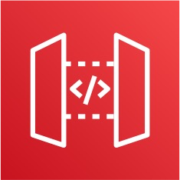

**Users**

REST API

**Lambda**

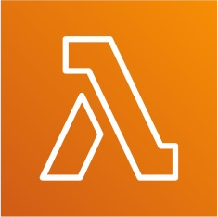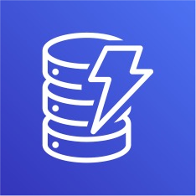

**DynamoDB**

## Why AWS Lambda

* + Virtual Servers in the Cloud
  + Limited by RAM and CPU
  + Continuously running

**Amazon EC2**

* Scaling means intervention to add / remove servers

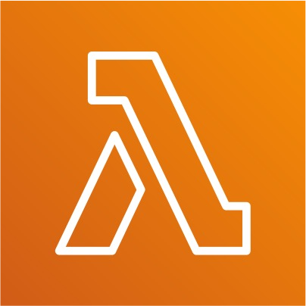

**Amazon Lambda**

* Virtual **functions** – no servers to manage!
* Limited by time - **short executions**
* Run **on-demand**
* **Scaling is automated**!

## Benefits of AWS Lambda

* Easy Pricing:
  + Pay per request and compute time
  + Free tier of 1,000,000 AWS Lambda requests and 400,000 GBs of compute time
* Integrated with the whole AWS suite of services
* Integrated with many programming languages
* Easy monitoring through AWS CloudWatch
* Easy to get more resources per functions (up to 10GB of RAM!)
* Increasing RAM will also improve CPU and network!

## AWS Lambda language support

* Node.js (JavaScript)
* Python
* Java (Java 8 compatible)
* C# (.NET Core)
* Golang
* C# / Powershell
* Ruby
* Custom Runtime API (community supported, example Rust)
* Lambda Container Image
  + The container image must implement the Lambda Runtime API
  + ECS / Fargate is preferred for running arbitrary Docker images

## AWS Lambda Integrations Main ones

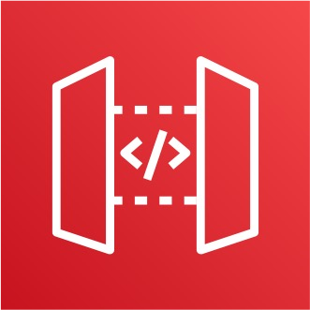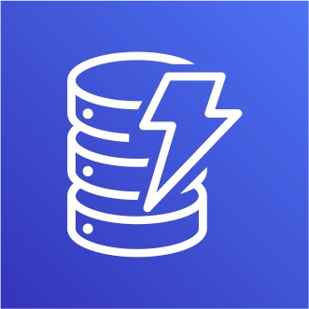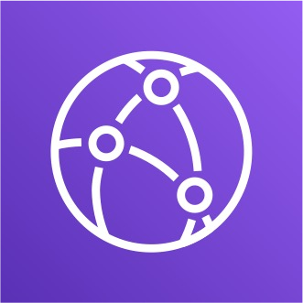

**API Gateway**

**Kinesis**

**DynamoDB S3**

**CloudFront**

    

**CloudWatch Events EventBridge**

**CloudWatch Logs SNS**

**SQS**

**Cognito**

## Example: Serverless Thumbnail creation

trigger



**New thumbnail in S3**

**New image in S3 AWS Lambda Function Creates a Thumbnail**

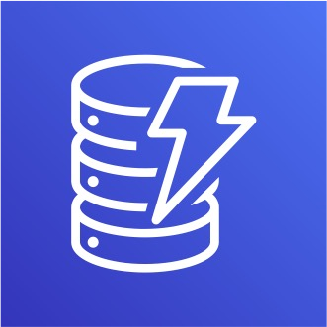

**Metadata in DynamoDB**

Image name Image size Creation date etc…

## Example: Serverless CRON Job

 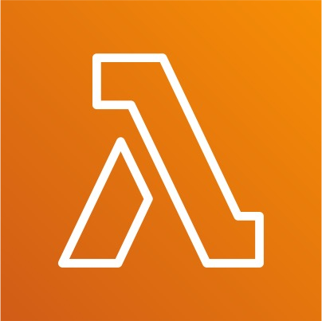

Trigger Every 1 hour

**CloudWatch Events EventBridge**

**AWS Lambda Function Perform a task**

## AWS Lambda Pricing: example

* You can find overall pricing information here: https://aws.amazon.com/lambda/pricing/
* Pay per calls:
  + First 1,000,000 requests are free
  + $0.20 per 1 million requests thereafter ($0.0000002 per request)
* Pay per duration: (in increment of 1 ms)
  + 400,000 GB-seconds of compute time per month for FREE

• == 400,000 seconds if function is 1GB RAM

• == 3,200,000 seconds if function is 128 MB RAM

* + After that $1.00 for 600,000 GB-seconds
* It is usually very cheap to run AWS Lambda so it’s very popular

## Lambda – Synchronous Invocations

* Synchronous: CLI, SDK, API Gateway, Application Load Balancer
  + Results is returned right away
  + Error handling must happen client side (retries, exponential backoff, etc…)

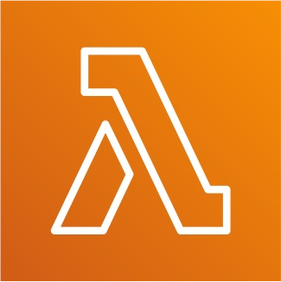invoke

SDK/CLI Do something

Response

Client

**API Gateway**

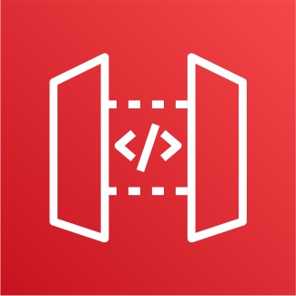

invoke

proxy

Response

Response

Do something

## Lambda - Synchronous Invocations - Services

* User Invoked:
  + Elastic Load Balancing (Application Load Balancer)
  + Amazon API Gateway
  + Amazon CloudFront (Lambda@Edge)
  + Amazon S3 Batch
* Service Invoked:
  + Amazon Cognito
  + AWS Step Functions
* Other Services:
  + Amazon Lex
  + Amazon Alexa
  + Amazon Kinesis Data Firehose

## Lambda Integration with ALB

* To expose a Lambda function as an HTTP(S) endpoint…
* You can use the Application Load Balancer (or an API Gateway)
* The Lambda function must be registered in a target group

**Client**



**HTTP/HTTPS**

**INVOKE**

**Target Group**

**SYNC**

**Application Load Balancer (ALB)**

## ALB to Lambda: HTTP to JSON

**Request Payload for Lambda Function**

ELB information

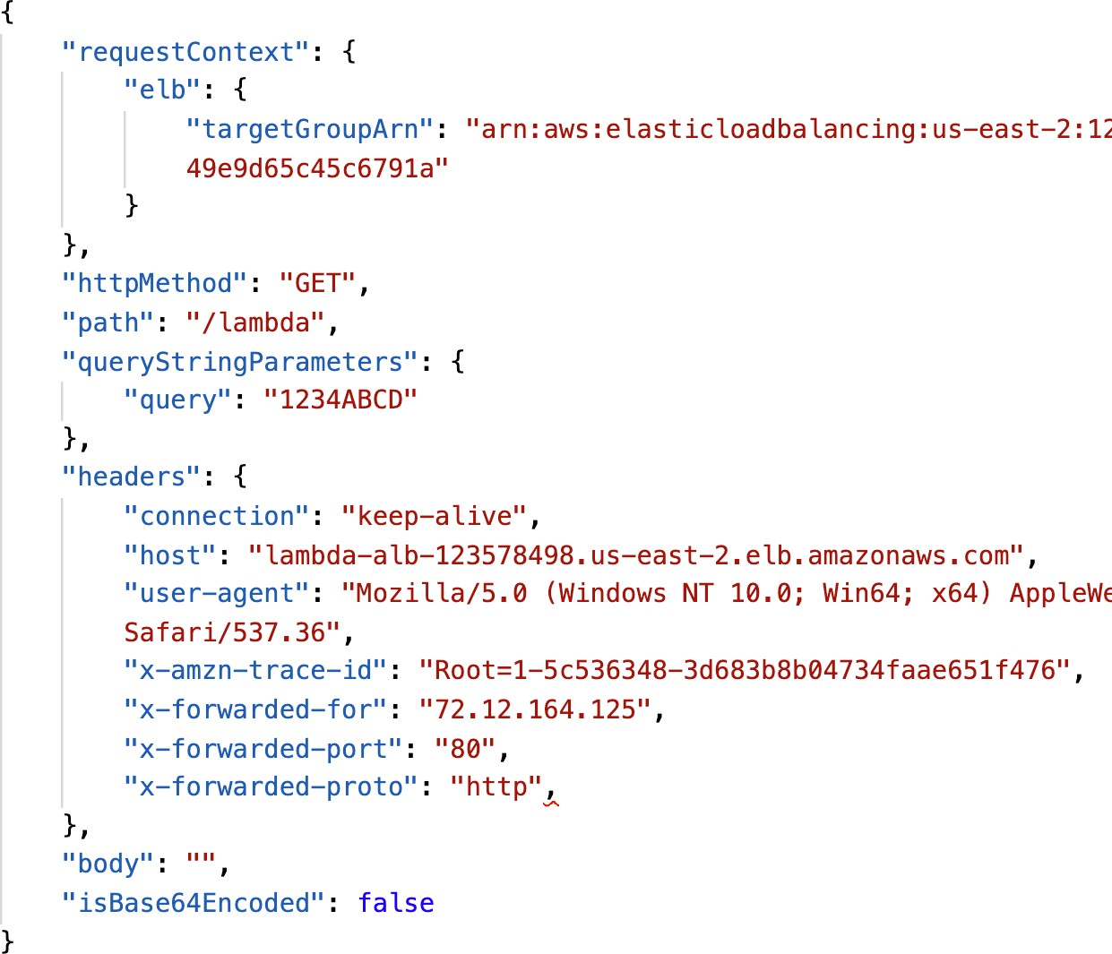

HTTP Method & Path

**Query String Parameters as Key/Value pairs**

**Headers as Key/Value pairs**

**Body (for POST, PUT...) & isBase64Encoded**

## Lambda to ALB conversions: JSON to HTTP

**Response from the Lambda Function**

Status Code & Description

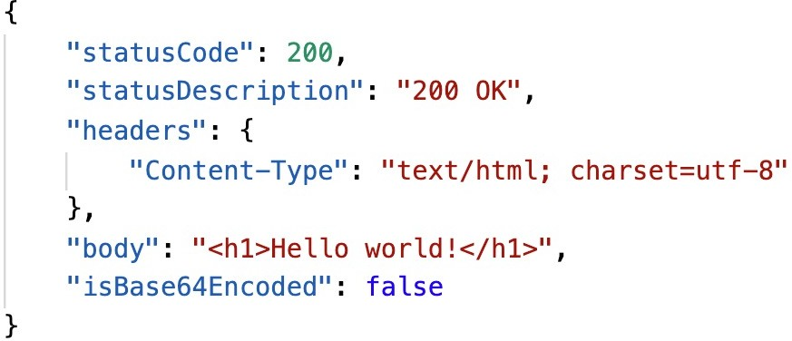

**Headers as Key/Value pairs Body & isBase64Encoded**

## ALB Multi-Header Values

* ALB can support multi header



**Client**

values (ALB setting)

* When you enable multi-value headers, HTTP headers and query string parameters that are sent with multiple values are shown as arrays within the AWS Lambda event and response objects.

**HTTP**

**JSON**

”queryStringParameters”: {“**name**”: **[“foo”,”bar”]** }

[http://example.com/path**?name=foo&name=bar**](http://example.com/path?name=foo&name=bar)



**ALB**



**Lambda**

## Lambda@Edge

* You have deployed a CDN using CloudFront
* What if you wanted to run a global AWS Lambda alongside?
* Or how to implement request filtering before reaching your application?
* For this, you can use Lambda@Edge:

deploy Lambda functions alongside your CloudFront CDN

* + Build more responsive applications
  + You don’t manage servers, Lambda is deployed globally
  + Customize the CDN content
  + Pay only for what you use

## Lambda@Edge

* You can use Lambda to change CloudFront requests and responses:
  + After CloudFront receives a request from a viewer (viewer request)
  + Before CloudFront forwards the request to the origin (origin request)
  + After CloudFront receives the response from the origin (origin response)
  + Before CloudFront forwards the response to the viewer (viewer response)

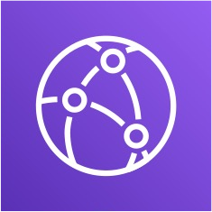Viewer Request Origin Request



Viewer Response

User

CloudFront

Origin Response

Origin

* You can also generate responses to viewers without ever sending the request to the origin.

## Lambda@Edge: Global application



**Amazon S3 bucket**

HTML Website



User visits website

Dynamic API requests

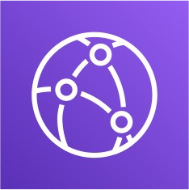

**CloudFront**



Query data

Cached Responses

**Lambda@Edge function**

Runs code in each CloudFront Edge, globally

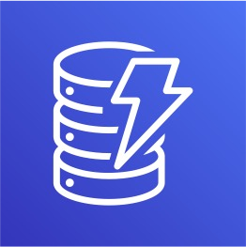

**Amazon DynamoDB**

## Lambda@Edge: Use Cases

* Website Security and Privacy
* Dynamic Web Application at the Edge
* Search Engine Optimization (SEO)
* Intelligently Route Across Origins and Data Centers
* Bot Mitigation at the Edge
* Real-time Image Transformation
* A/B Testing
* User Authentication and Authorization
* User Prioritization
* User Tracking and Analytics

## Lambda – Asynchronous Invocations

* S3, SNS, CloudWatch Events…

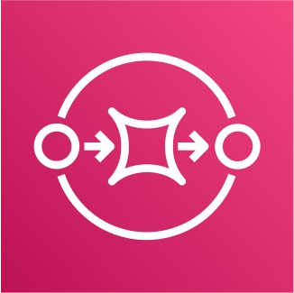

Lambda Service

retries

New file event

read

S3 bucket

**Event Queue**

**Function**

DLQ for

failed processing

**SQS or SNS**

* The events are placed in an Event Queue
* Lambda attempts to retry on errors
* 3 tries total
  + 1 minute wait after 1st , then 2 minutes wait
* Make sure the processing is idempotent (in case of retries)
* If the function is retried, you will see duplicate logs entries in CloudWatch Logs
* Can define a DLQ (dead-letter queue) – SNS or SQS – for failed processing (need correct IAM permissions)
* Asynchronous invocations allow you to speed up the processing if you don’t need to wait for the result (ex: you need 1000 files processed)

## Lambda - Asynchronous Invocations - Services

* Amazon Simple Storage Service (S3)
* Amazon Simple Notification Service (SNS)
* Amazon CloudWatch Events / EventBridge
* AWS CodeCommit (CodeCommit Trigger: new branch, new tag, new push)
* AWS CodePipeline (invoke a Lambda function during the pipeline, Lambda must callback)

other

* Amazon CloudWatch Logs (log processing)
* Amazon Simple Email Service
* AWS CloudFormation
* AWS Config
* AWS IoT
* AWS IoT Events

## CloudWatch Events / EventBridge

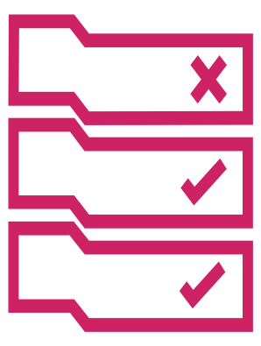**CRON or Rate EventBridge Rule**

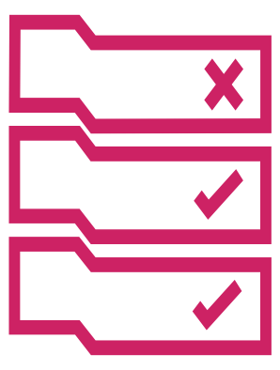**CodePipeline EventBridge Rule**

**AWS Lambda Function Perform a task**

**AWS Lambda Function Perform a task**

Trigger Every 1 hour

Trigger on

**State Changes**

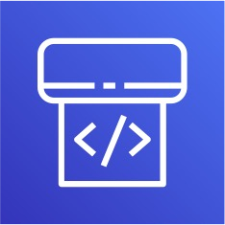

## S3 Events Notifications

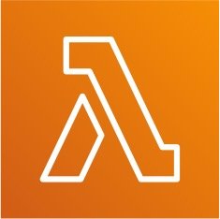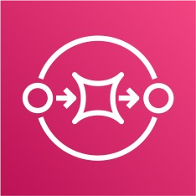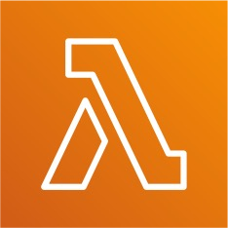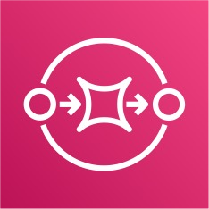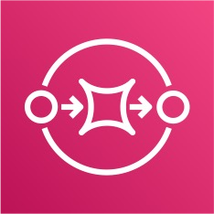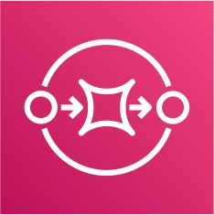

* S3:ObjectCreated, S3:ObjectRemoved, S3:ObjectRestore, S3:Replication…
* Object name filtering possible (*.jpg)
* Use case: generate thumbnails of images uploaded to S3
* S3 event notifications typically deliver events

in seconds but can sometimes take a minute

events

SNS

SQS

or longer

* If two writes are made to a single non- versioned object at the same time, it is possible that only a single event notification will be sent

Amazon S3

*async*

SQS Lambda Function

* If you want to ensure that an event notification is sent for every successful write, you can enable versioning on your bucket.

Lambda Function

DLQ

SQS

## Simple S3 Event Pattern – Metadata Sync

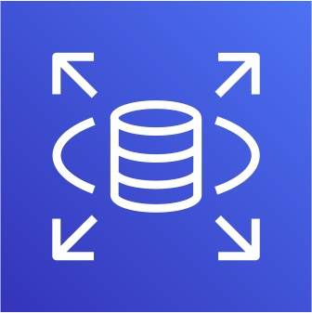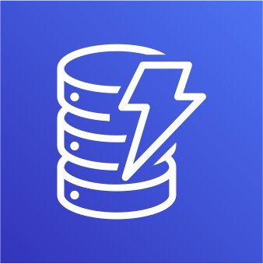

New file event

**Table in RDS**

S3 bucket

Update metadata table

**DynamoDB Table**

## Lambda – Event Source Mapping

* Kinesis Data Streams



* SQS & SQS FIFO queue

Kinesis

* DynamoDB Streams
* Common denominator: records need to be polled from the source
* Your Lambda function is invoked synchronously

POLL RETURN BATCH



**Event Source Mapping**

(internal)

INVOKE WITH EVENT BATCH



Lambda Function